RAJALAKSHMI ENGINEERING COLLEGE RAJALAKSHMI NAGAR, THANDALAM – 602 105



**CS23332 DATABASE MANAGEMENT**

**SYSTEMS LAB**

**Laboratory Record Notebook**

Name: ENIYA . B. A

Year / Branch / Section: II Year CSE-B University Register No: 2116230701085

College Roll No: 230701085

Semester: III

Academic Year: 2024-25

**CS23332 DATABASE MANAGEMENT SYSTEMS**

|  |  |
| --- | --- |
| **NAME** | **BALAJI C** |
| **ROLL NO.** | **2116230701049** |
| **DEPT** | **CSE** |
| **SEC** | **‘A’** |

|  |  |  |
| --- | --- | --- |
| **Ex.No.: 1** | | **CREATION OF BASE TABLE AND DML OPERATIONS** |
| **Date:** | 01/08/2024 |

1. Create MY_EMPLOYEE table with the following structure

CREATE TABLE MY_EMPLOYEE( ID Number(4) NOT NULL,

Last_name Varchar(25), First_name Varchar(25), Userid Varchar(25), Salary Number(9,2)

);

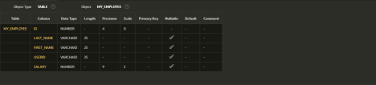

1. Add the first row and second rows data to MY_EMPLOYEE table fromthe sample table

Insert  MY_EMPLOYEE(&ID,&LAST_NAME,&FIRST_NAME,&USERID,&SALARY

)

values(1,”Patel”,”Ralph”,”rpatel”,895 2,”Dancs”,”Betty”,”bdancs”,860);

1. Display the table with values Select * from MY_EMPLOYEE;

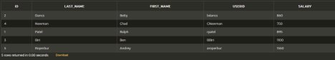

1. populate the next two rows of data from the sample data. Concatenate the first letter of the first_NAME with first seven letters of the last_name toproduce Userid

Update MY_EMPLOYEES

Set Userid = substr(first_name,1,1) || substr(last_name,1,7) Where ID in (3,4);

1. delete Betty dancs from my_employee table`1Delete from MY_EMPLOYEE

Where FIRST_NAME = ‘Betty’ and LAST_NAME = ‘Dancs’;

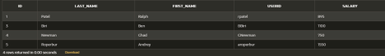

1. Empty the fourth row of the emp table Delete from MY_EMPLOYEE

Where ID = 5;



1. Make the data additions permanentCommit;
2. Change the last name of employee 3 to Drexler

Update MY_EMPLOYEE Set LAST_NAME = “Drexler” Where ID = 3;



1. Change the salary to 1000 for all the employees with a salary less than900.

Update MY_EMPLOYEE Set salary = 1000

Where salary<900;



|  |  |  |
| --- | --- | --- |
| **Ex.No.: 2** | | **DATA MANIPULATIONS** |
| **Date:** | 08/08/2024 |

1. Find out the employee id, names, salaries of all the employeesselect Employee_id, First_Name, Salary from EMPLOYEES;

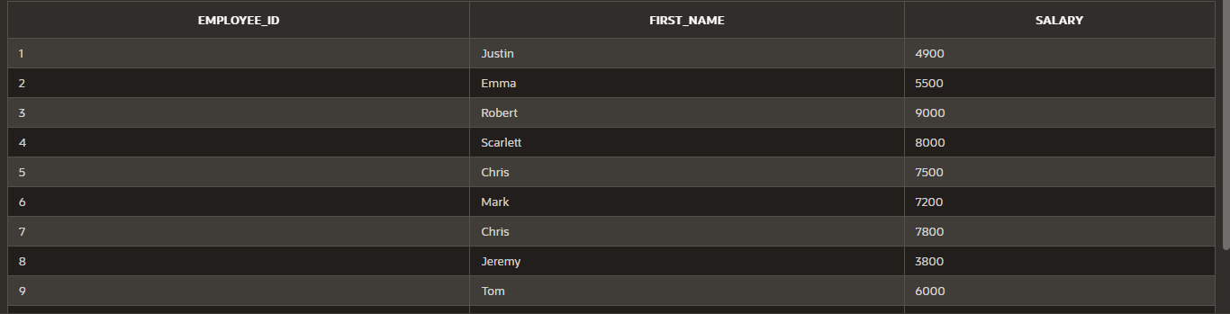

1. List out the employees who works under manager 100

select First_Name || ' ' || Last_Name as name from EMPLOYEES where manager_id

=100;

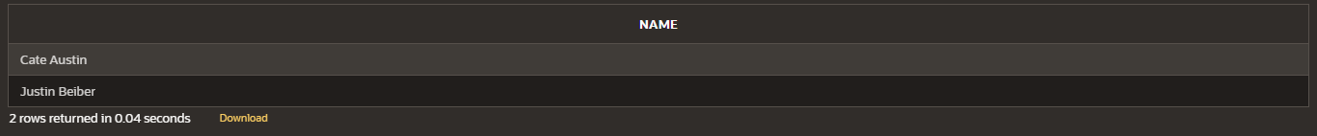

1. Find the names of the employees who have a salary greater than or equal to 4800

select First_Name || ' ' || Last_Name as name from EMPLOYEES Where salary >= 4800;

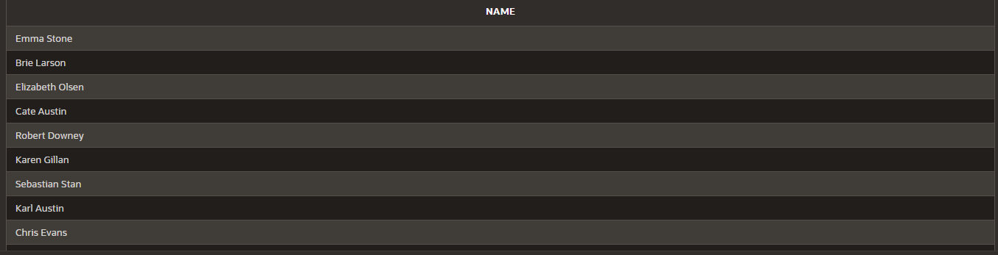

1. List out the employees whose last name is A̳ USTIN

select First_Name || ' ' || Last_Name as name from EMPLOYEES where Last_Name = 'Austin';

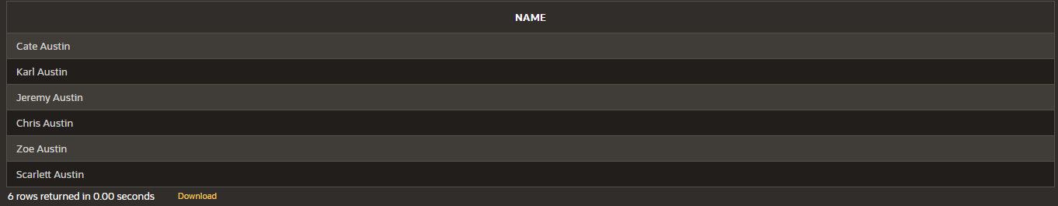

1. Find the names of the employees who works in departments 60,70 and 80

select First_Name || ' ' || Last_Name as name from EMPLOYEES where Department_id in (60,70,80);

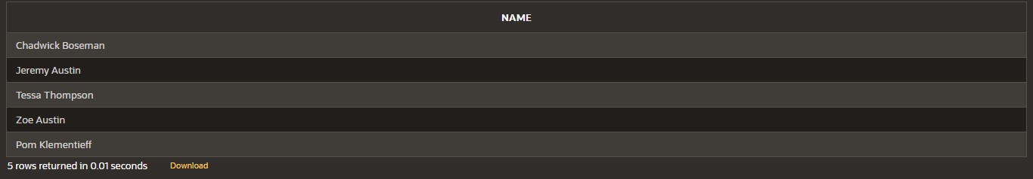

1. Display the unique Manager_Id.

select DISTINCT(manager_id) from EMPLOYEES;

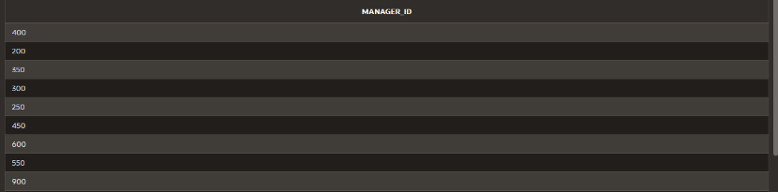

1. Insert Five Records and calculate GrossPay and NetPay.

INSERT INTO Emp (EmpNo, EmpName, Job, Basic, DA, HRA, PF, GrossPay, NetPay) VALUES (

101, 'John Doe', 'Manager', 50000, 15000, 20000, 6000,0,0 ,

102, 'Jane Smith', 'Developer', 40000, 12000, 16000, 4800,0,0 ,

103, 'Alice Johnson', 'Analyst', 35000, 10500, 14000, 4200,0,0 ,

104, 'Bob Brown', 'Designer', 30000, 9000, 12000, 3600,0,0 ,

105, 'Charlie Davis', 'Tester', 25000, 7500, 10000, 3000,0,0

)

update emp

set GrossPay = Basic+DA+HRA where Grosspay = 0;

update emp

set NetPay = Grosspay - PF where Netpay = 0;

1. Display the employees whose Basic is lowest in each department. select job,min(basic) from Emp

group by Job;

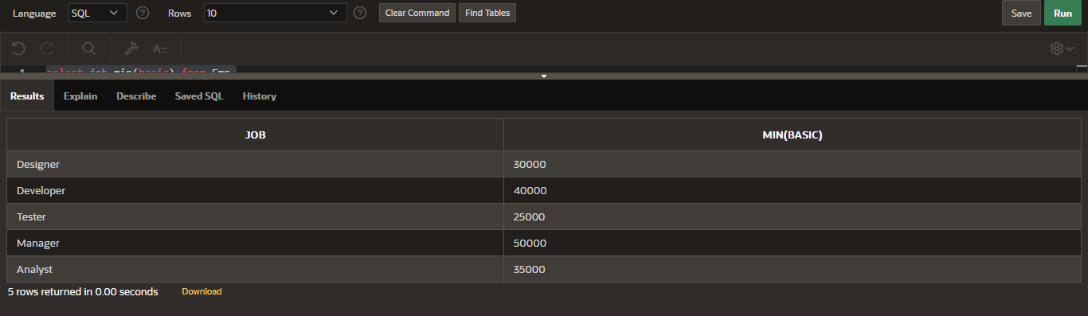

1. Create the DEPT table based on the DEPARTMENT following the table instance chart below. Confirm that the table is created.

Create table DEPT(

ID Number(7), Name varchar(25)

);

Desc DEPT;

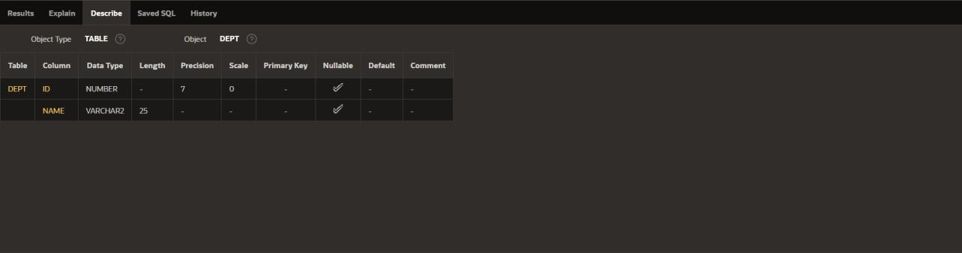

1. Create the EMP1 table based on the following instance chart. Confirm that the table is created.

create table EMP1( ID Number(7),

First_name varchar(25), Last_name varchar(25), Dept_id Number(7)

);

Desc EMP1;

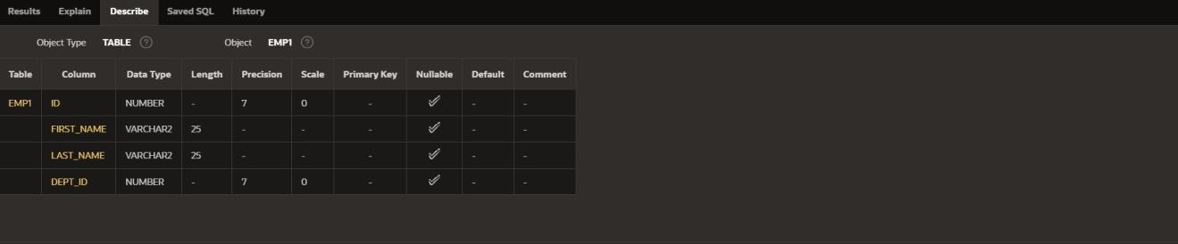

1. Modify the EMP1 table to allow for longer employee last names. Confirm the modification.(Hint: Increase the size to 50)

# ALTER TABLE EMP1

modify Last_name varchar(50);

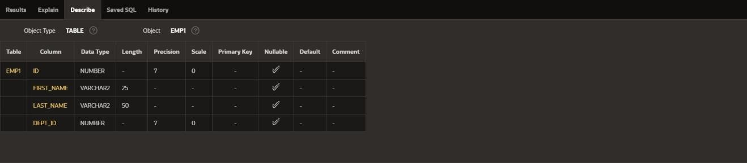

1. Create the EMPLOYEES2 table based on the structure of EMPLOYEES table. Include Only the Employee_id, First_name, Last_name, Salary and Dept_id coloumns. Name the columns Id, First_name, Last_name, salary and Dept_id respectively.

create table EMPLOYEES2( ID Number(10), First_name varchar(50), Last_name varchar(50), Salary Number(10), Dept_id Number(10)

);

1. Drop the EMP1 table. drop table EMP1;
2. Rename the EMPLOYEES2 table as EMP1.

# ALTER TABLE EMPLOYEES2 RENAME TO EMP1;

1. Add a comment on DEPT and EMP1 tables. Confirm the modification by describing the table.

comment on TABLE DEPT IS 'this table contains the fields ID and NAME..'; SELECT TABLE_NAME, COMMENTS

# FROM USER_TAB_COMMENTS

WHERE TABLE_NAME = 'DEPT';

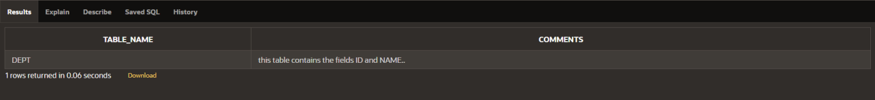

comment on TABLE EMP1 IS 'this table contains the fields ID,first name,last name,salary,DEPT_id..';

# SELECT TABLE_NAME, COMMENTS FROM USER_TAB_COMMENTS WHERE TABLE_NAME = 'EMP1';

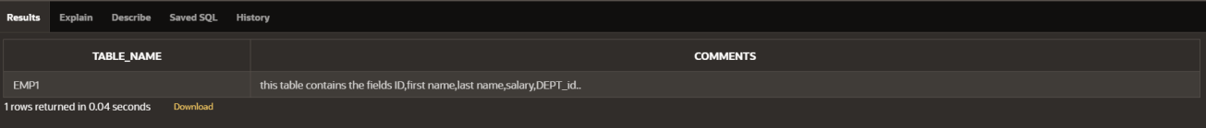

1. Drop the First_name column from the EMP table and confirm it.

# ALTER TABLE EMP1

drop column First_name;

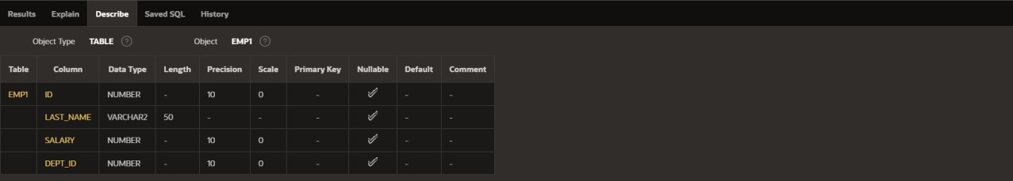

|  |  |  |
| --- | --- | --- |
| **Ex.No.: 3** | | **WRITING BASIC SQL SELECT STATEMENTS** |
| **Date:** | 10/08/2024 |

Find the Solution for the following:

True OR False

1. The following statement executes successfully.

Identify the Errors

SELECT employee_id, last_name sal*12 ANNUAL SALARY

FROM employees;

FALSE

The columns in select statement should be separated by commas and the column alias should be given by using a keyword “as”

SELECT employee_id, last_name, salary*12 as "ANNUAL SALARY" FROM employees;

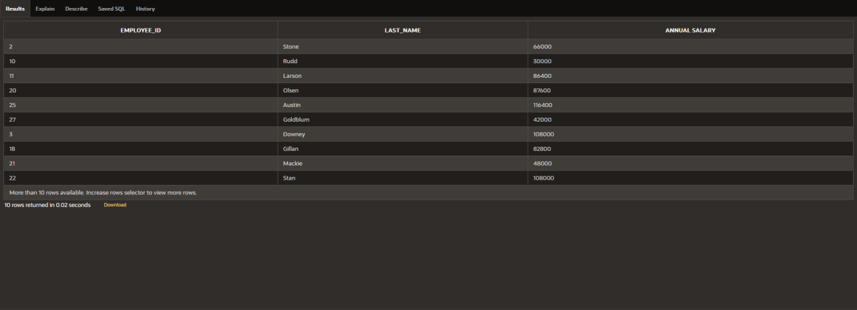

2) Show the structure of departments the table. Select all the data from it.

Desc employees;

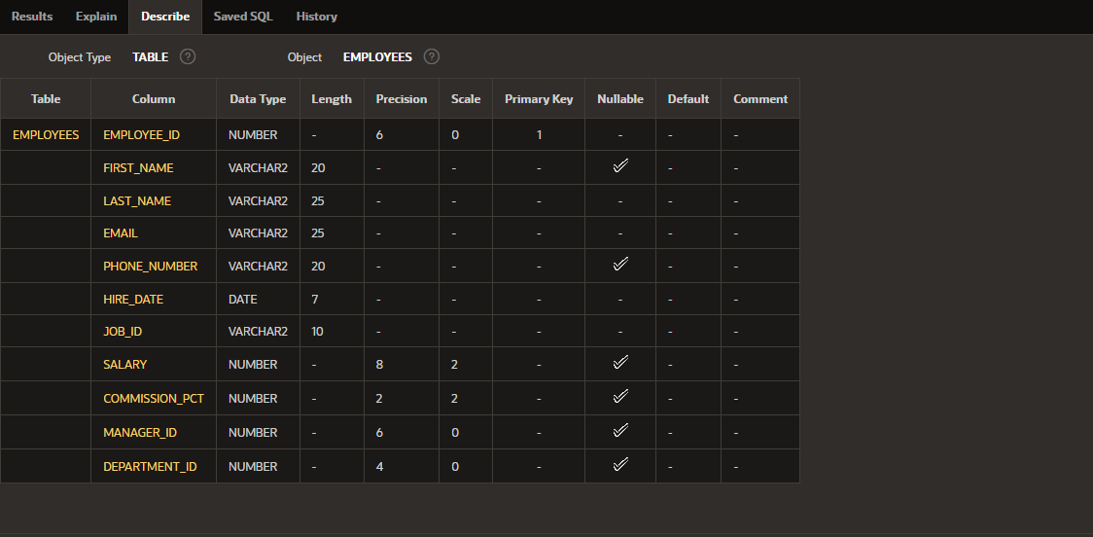

1. Create a query to display the last name, job code, hire date, and employee number for each employee, with employee number appearing first.

select employee_id , job_id , last_name , hire_date from employees;

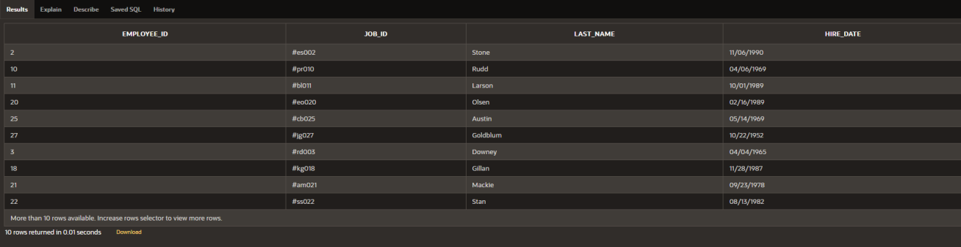

1. Provide an alias STARTDATE for the hire date. select hire_date as "STARTDATE" from employees;

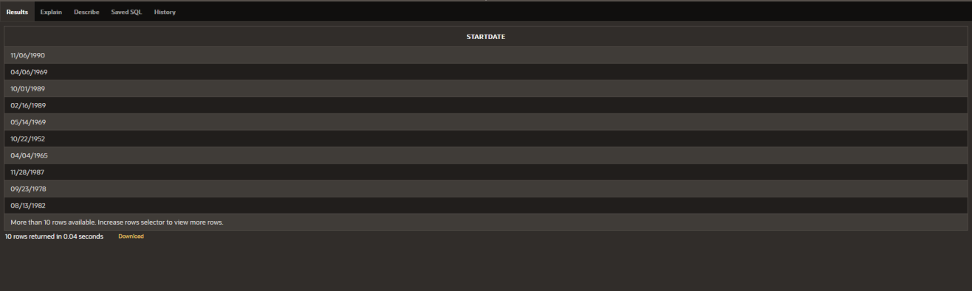

1. Create a query to display unique job codes from the employee table. select distinct(job_id) from employees;

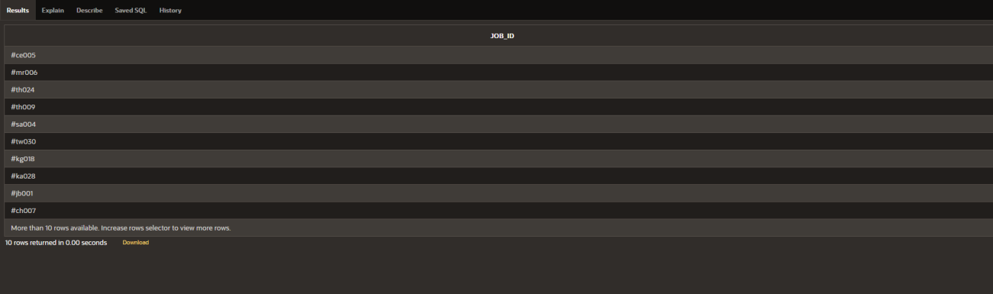

1. Display the last name concatenated with the job ID , separated by a comma and space, and name the column EMPLOYEE and TITLE.

select last_name || ' ' || ',' || ' ' || job_id as "EMPLOYEE AND TITLE" from employees;

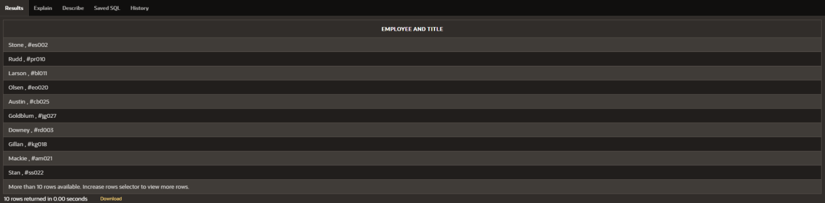

1. Create a query to display all the data from the employees table. Separate each column by a comma. Name the column THE_OUTPUT.

select employee_id || ' , ' || first_name || ' , ' || last_name || ' , ' || email || ' , ' || phone_number || ' , ' || hire_date || ' , ' || job_id || ' , ' || salary || ' , ' || commission_pct || ' , ' || manager_id || ' , ' || department_id as "THE_OUTPUT"

from employees;

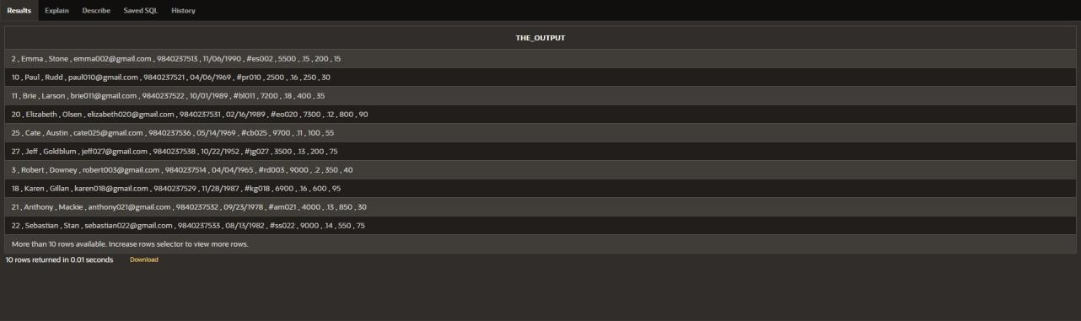

|  |  |  |
| --- | --- | --- |
| **Ex.No.: 4** | | **WORKING WITH CONSTRAINTS** |
| **Date:** | 16/08/2024 |

* 1. Add a table-level PRIMARY KEY constraint to the EMP table on the ID column.The constraint should be named at creation. Name the constraint my_emp_id_pk.

alter table EMP1

add constraint my_emp_id_pk PRIMARY KEY(ID);

* 1. Create a PRIMAY KEY constraint to the DEPT table using the ID colum. The constraint should be named at creation. Name the constraint my_dept_id_pk.

alter table DEPT

add constraint my_dept_id_pk PRIMARY KEY(ID);

* 1. Add a column DEPT_ID to the EMP table. Add a foreign key reference on the EMP table that ensures that the employee is not assigned to nonexistent deparment. Name the constraint my_emp_dept_id_fk.

alter table emp

add DEPT_ID Numbe(10);

alter table emp

add constraint my_emp_dept_id_fk FOREIGN KEY(DEPT_ID) references dept(ID);

* 1. Modify the EMP table. Add a COMMISSION column of NUMBER data type, precision 2, scale 2. Add a constraint to the commission column that ensures that a commission value is greater than zero.

alter table emp

add COMMISSION Number(2,2);

alter table emp

add CONSTRAINT commission_gt_zero CHECK(COMMISSION > 0);

|  |  |  |
| --- | --- | --- |
| **Ex.No.: 5** | | **CREATING VIEWS** |
| **Date:** | 23/08/2024 |

1. Create a view called EMPLOYEE_VU based on the employee numbers, employee names and department numbers from the EMPLOYEES table. Change the heading for the employee name to EMPLOYEE.

create view EMPLOYEE_VU as

select employee_id , first_name || ' ' || last_name as "EMPLOYEE", department_id from employees;

1. Display the contents of the EMPLOYEES_VU view. select * from EMPLOYEE_VU;

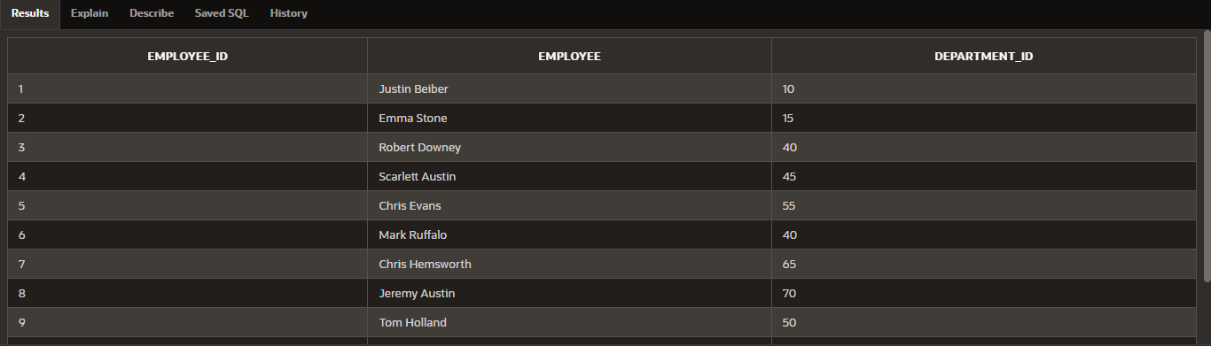

1. Select the view name and text from the USER_VIEWS data dictionary views. select VIEW_NAME, TEXT

from USER_VIEWS

where VIEW_NAME = 'EMPLOYEE_VU';



1. Using your EMPLOYEES_VU view, enter a query to display all employees names and Department.

SELECT employee, department_id

FROM EMPLOYEE_VU;

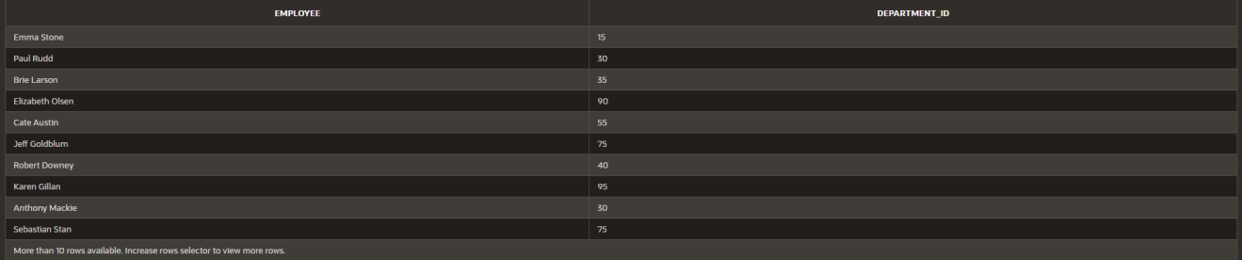

1. Create a view named DEPT50 that contains the employee number, employee last names and department numbers for all employees in department 50.Label the view columns EMPNO, EMPLOYEE and DEPTNO. Do not allow an employee to be reassigned to another department through the view.

CREATE VIEW DEPT50 AS

SELECT employee_id AS EMPNO, employee AS EMPLOYEE, department_id AS DEPTNO

FROM EMPLOYEE_VU

WHERE department_id = 50 WITH READ ONLY;



1. Display the structure and contents of the DEPT50 view.

Desc dept50;

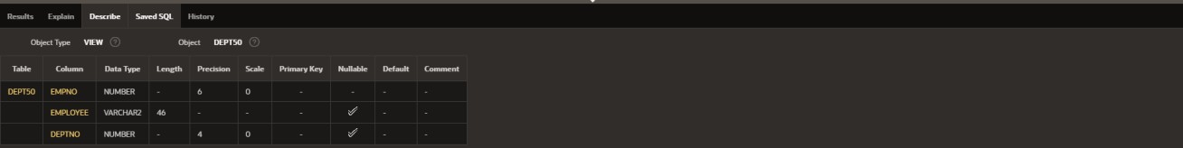

1. Attempt to reassign Matos to department 80.

UPDATE EMPLOYEES

SET department_id = 80 WHERE first_name = 'Matos';

1. Create a view called SALARY_VU based on the employee last names, department names, salaries, and salary grades for all employees. Use the Employees, DEPARTMENTS and JOB_GRADE tables. Label the column Employee, Department, salary, and Grade respectively.

CREATE VIEW SALARY_VU AS

SELECT e.last_name AS Employee, d.dept_name AS Department, e.salary AS Salary, j.grade_level AS Grade

FROM EMPLOYEES e JOIN DEPARTMENT d

ON e.department_id = d.dept_id JOIN JOB_GRADE j

ON e.salary BETWEEN j.lowest_sal AND j.highest_sal;

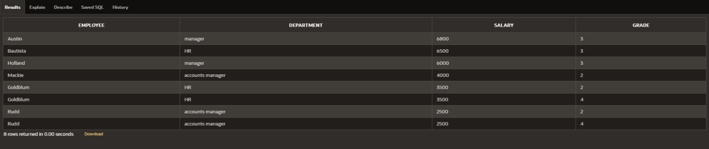

|  |  |  |
| --- | --- | --- |
| **Ex.No.: 6** | | **RESTRICTING AND SORTING DATA** |
| **Date:** | 29/08/2024 |

1. Create a query to display the last name and salary of employees earning more than 12000.

select salary , last_name from employees where salary > 12000;

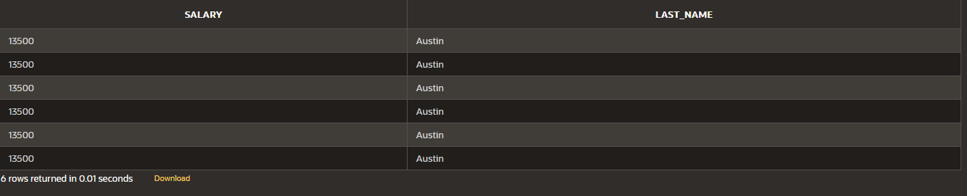

1. Create a query to display the employee last name and department number for employee number 176.

select last_name , department_id from employees where employee_id = 176;



1. Create a query to display the last name and salary of employees whose salary is not in the range of 5000 and 12000.

select last_name , salary from employees where salary not between 5000 and 12000;

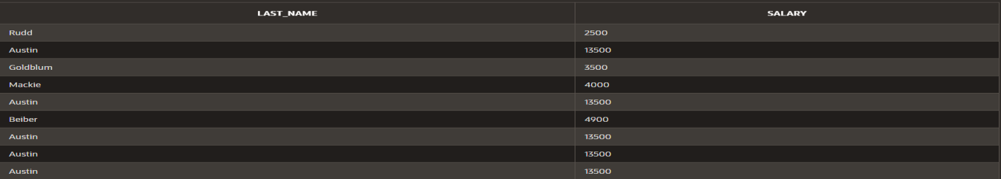



1. Display the employee last name, job ID, and start date of employees hired between February 20,1998 and May 1,1998.order the query in ascending order by start date.(hints: between)

select last_name, job_id, hire_date from employees where hire_date between '02-20-1998' and '05-01-1998';



1. Display the last name and department number of all employees in departments 20 and 50 in alphabetical order by name.

select last_name, department_id from employees where department_id = 20 or department_id = 50 order by last_name;

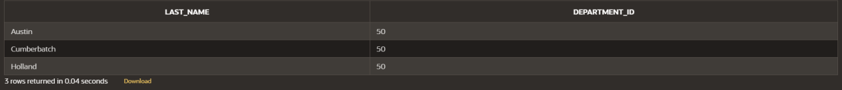

1. Display the last name and salary of all employees who earn between 5000 and 12000 and are in departments 20 and 50 in alphabetical order by name. Label the columns EMPLOYEE, MONTHLY SALARY respectively.

select last_name as "EMPLOYEE" , salary as "MONTHLY SALARY" from employees where department_id in (20,50) and salary between 5000 and 12000

order by last_name;



1. Display the last name and hire date of every employee who was hired in 1994. select last_name, hire_date from employees

where hire_date like '%1994%';



1. Display the last name and job title of all employees who do not have a manager

select e.last_name, d.dept_name from employees e join department d

on e.department_id = d.dept_id where not(dept_name = 'manager');

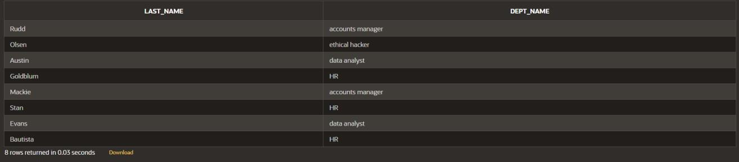

1. Display the last name, salary, and commission for all employees who earn commissions. Sort data in descending order of salary and commissions.(hints: is not nul,orderby)

select last_name,salary,commission_pct from employees where commission_pct is not null

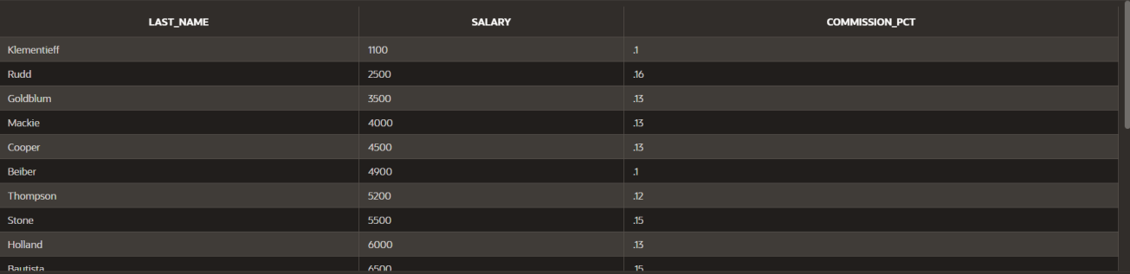order by salary,commission_pct desc;

1. Display the last name of all employees where the third letter of the name is a. select last_name from employees

where last_name like 'a%';

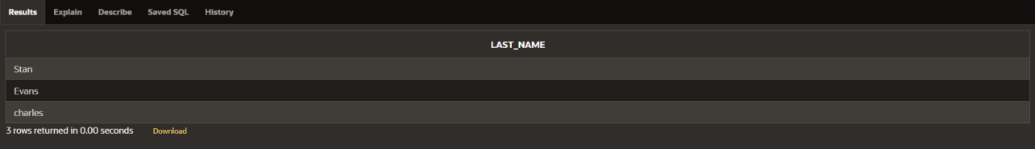

1. Display the last name of all employees who have an a and an e in their last name.

SELECT last_name FROM employees

WHERE last_name LIKE '%a%' AND last_name LIKE '%e%';

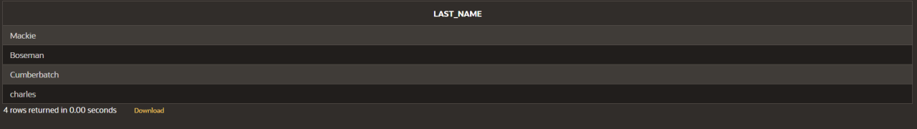

1. Display the last name and job and salary for all employees whose job is sales representative or stock clerk and whose salary is not equal to 2500 ,3500 or 7000/.

SELECT e.last_name,e.salary,d.dept_name FROM employees e join department d on e.department_id = d.dept_id

WHERE (dept_name in ('stock clerk','sales representative')) and (salary not in(2500,3500,7000));



|  |  |  |
| --- | --- | --- |
| **Ex.No.: 7** | | **USING SET OPERATORS** |
| **Date:** | 30/08/2024 |

1. The HR department needs a list of department IDs for departments that do not contain the job ID ST_CLERK. Use set operators to create this report.

select dept_id from department minus

select department_id from employees where job_id = 'ST_CLERK';

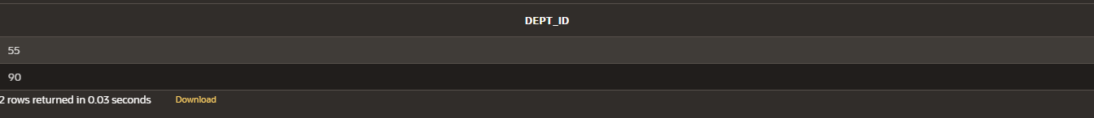

1. The HR department needs a list of countries that have no departments located in them.Display the country ID and the name of the countries. Use set operators to create this report.

SELECT c.country_id, c.country_name FROM countries c

LEFT JOIN department d ON c.country_id = d.country_id WHERE d.country_id IS NULL;



1. Produce a list of jobs for departments 10, 50, and 20, in that order. Display job ID and department ID using set operators.

SELECT job_id, department_id FROM employees

WHERE department_id IN (10, 50, 20) ORDER BY department_id;

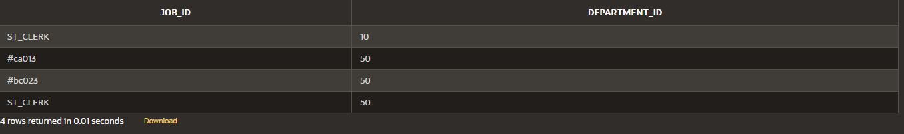

1. Create a report that lists the employee IDs and job IDs of those employees who currently have a job title that is the same as their job title when they were initially hired by the company (that is, they changed jobs but have now gone back to doing their original job).

SELECT employee_id, job_id FROM employees INTERSECT

SELECT employee_id, job_id FROM job_history;

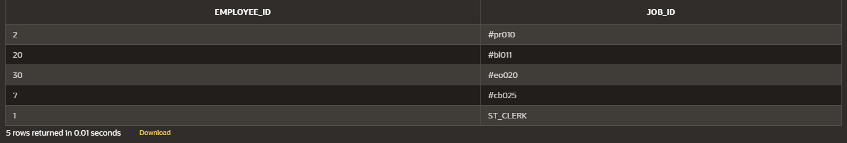

1. The HR department needs a report with the following specifications:
   * Last name and department ID of all the employees from the EMPLOYEES table, regardless of whether or not they belong to a department.
   * Department ID and department name of all the departments from the DEPARTMENTS table, regardless of whether or not they have employees working in them Write a compound query to accomplish this.

SELECT last_name, department_id FROM employees UNION

SELECT dept_name, dept_id FROM department;

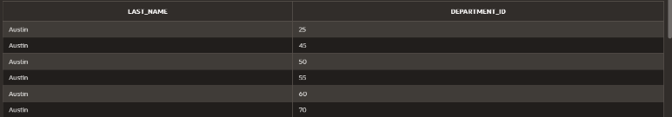

|  |  |  |
| --- | --- | --- |
| **Ex.No.: 8** | | **WORKING WITH MULTIPLE TABLES** |
| **Date:** | 05/09/2024 |

1. Write a query to display the last name, department number, and department name for all Employees.

select e.last_name , e.department_id , d.dept_name from employees e

join department d on e.department_id = d.dept_id;

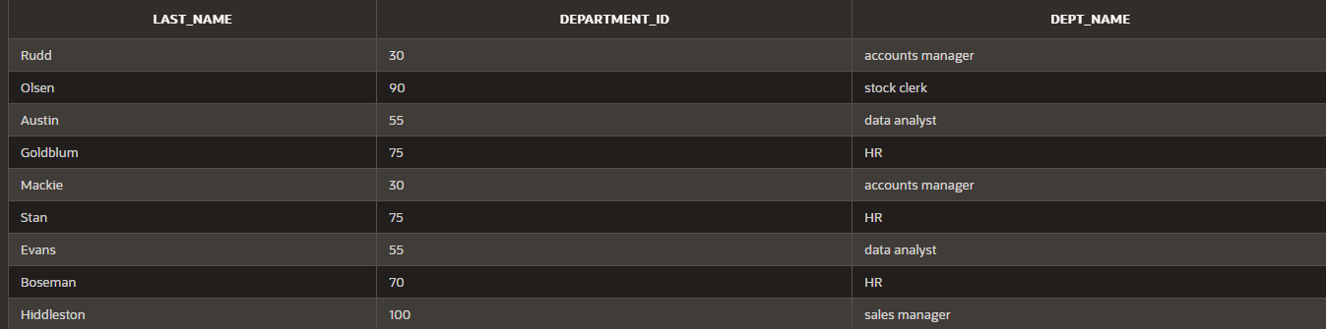

1. Create a unique listing of all jobs that are in department 80. Include the location of the department in the output.

select d.dept_name,d.location_id from department d

join employees e on d.dept_id = e.department_id where department_id = 80;

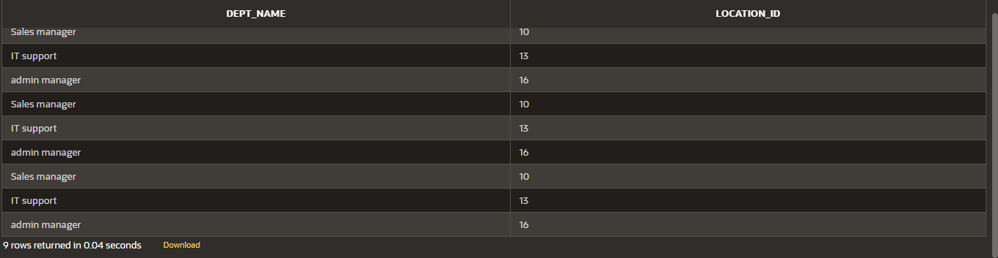

1. Write a query to display the employee last name, department name, location ID, and city of all employees who earn a commission

select e.last_name,d.dept_name,d.location_id,l.city from (department d

inner join employees e on d.dept_id = e.department_id inner join location l on d.location_id = l.location_id) where commission_pct is not null;

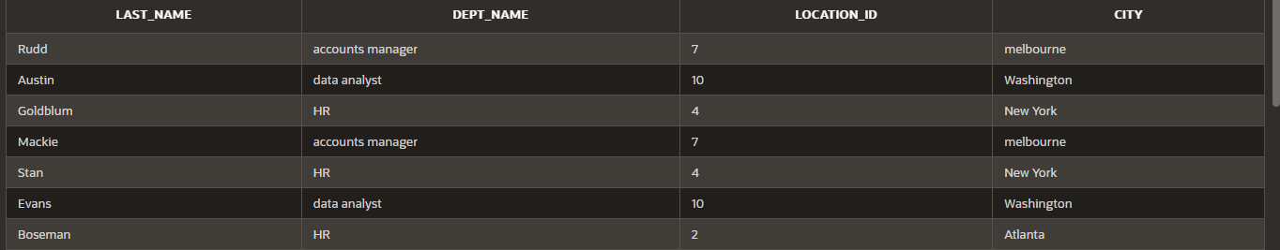

1. Display the employee last name and department name for all employees who have an a(lowercase) in their last names.

select e.last_name,d.dept_name from department d

inner join employees e on d.dept_id = e.department_id where last_name like '%a%';

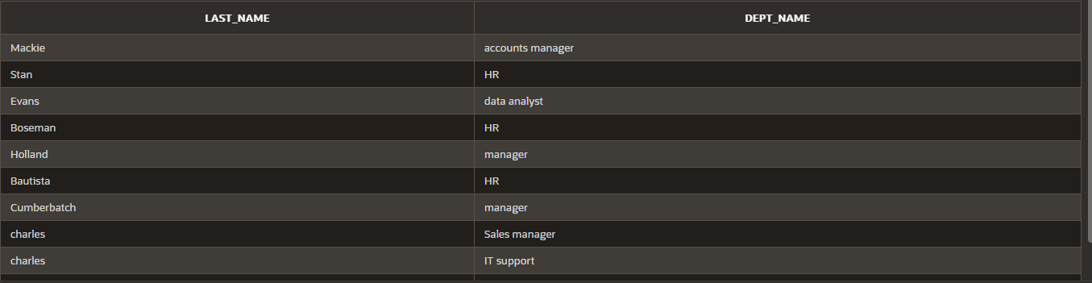

1. Write a query to display the last name, job, department number, and department name for all employees who work in Toronto.

select e.last_name,d.dept_name,e.department_id from (department d

inner join employees e on d.dept_id = e.department_id inner join location l on l.location_id = d.location_id) where city = 'Toronto';

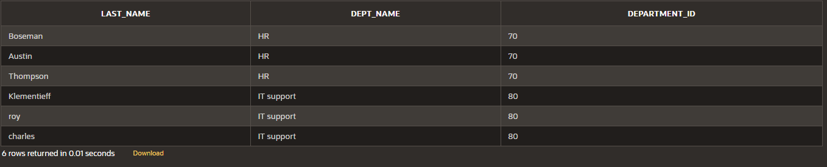

1. Display the employee last name and employee number along with their manager‘s last name and manager number. Label the columns Employee, Emp#, Manager, and Mgr#,

Respectively

select last_name as "Employee",employee_id as "Emp#",manager_id as "Mgr#" from employees;

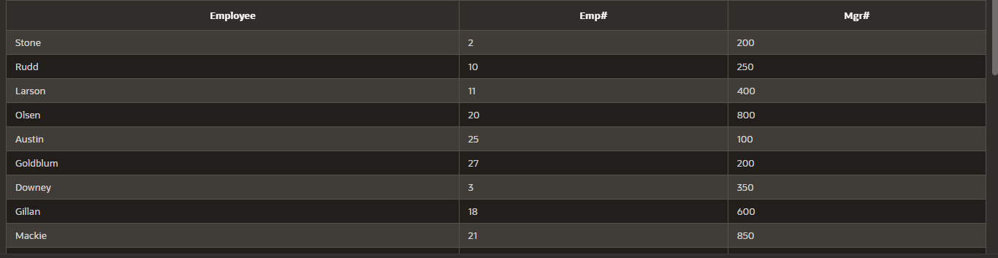

1. Modify lab4_6.sql to display all employees including King, who has no manager. Order the results by the employee number.

SELECT last_name AS "Employee",employee_id AS "Emp#",manager_id AS "Mgr#" FROM employees ORDER BY employee_id;

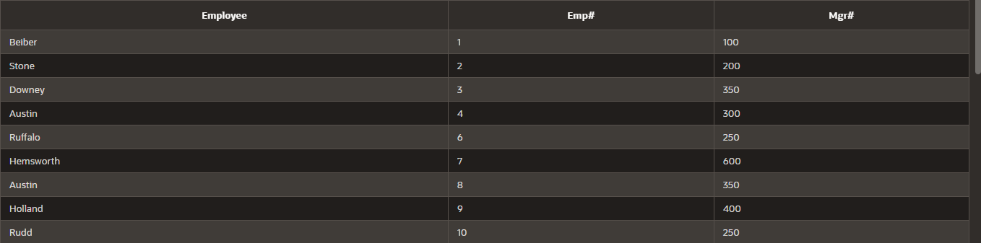

1. Create a query that displays employee last names, department numbers, and all the employees who work in the same department as a given employee. Give each column an appropriate label

select e.last_name as "Employee",d.dept_name as "department_name",e.department_id as "department_no" from employees e

inner join department d on e.department_id = d.dept_id;

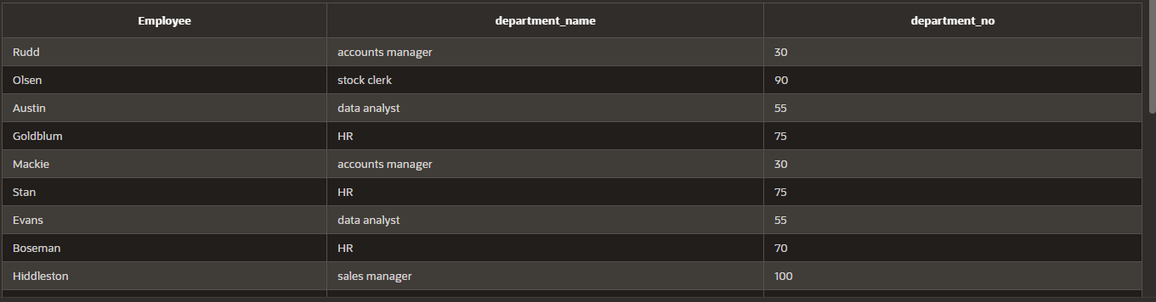

1. Show the structure of the JOB_GRADES table. Create a query that displays the name, job, department name, salary, and grade for all employees

desc job_grade;

SELECT e.first_name || ' ' || last_name AS "Employee",d.dept_name,e.salary,g.grade_level as"GRADE"

FROM (employees e

inner join department d on e.department_id = d.dept_id

inner join job_grade g on e.department_id = g.department_id);

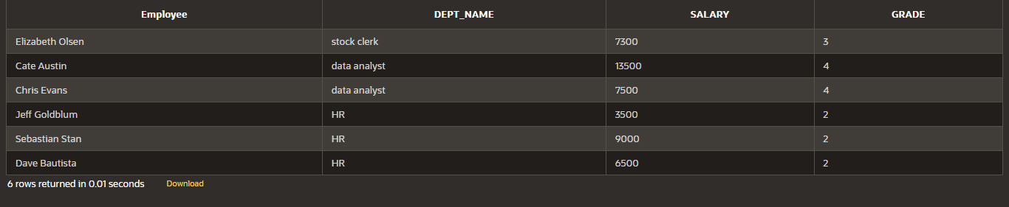

1. Create a query to display the name and hire date of any employee hired after employee Davies.

SELECT last_name,hire_date FROM employees where hire_date > '05-03-1986';

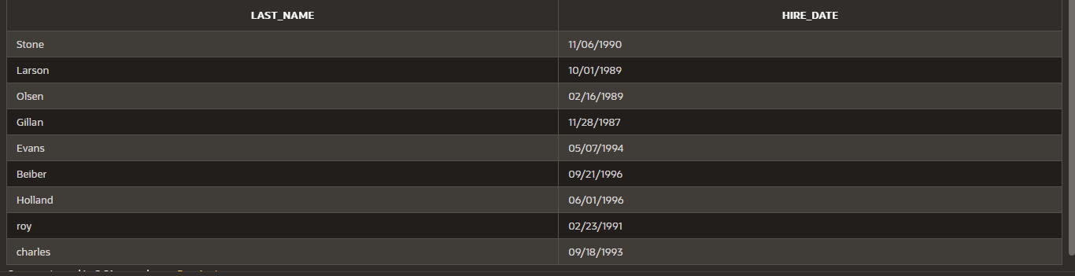

1. Display the names and hire dates for all employees who were hired before their managers, along with their manager‘s names and hire dates. Label the columns Employee, Emp Hired, Manager, and Mgr Hired, respectively.

SELECT last_name as "employee",hire_date as "employee hired" FROM employees;

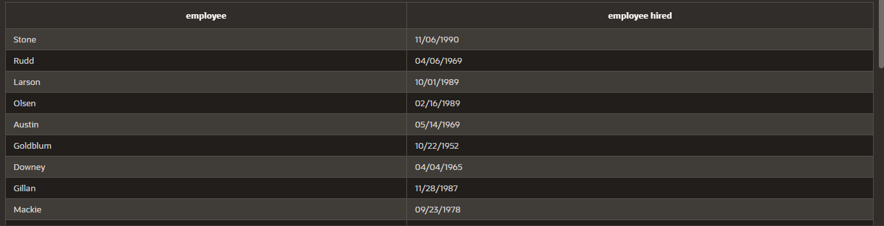

|  |  |  |
| --- | --- | --- |
| **Ex.No.: 9** | | **SUB QUERIES** |
| **Date:** | 06/09/2024 |

* 1. The HR department needs a query that prompts the user for an employee last name. The query then displays the last name and hire date of any employee in the same department as the employee whose name they supply (excluding that employee). For example, if the user enters Zlotkey, find all employees who work with Zlotkey (excludingZlotkey).

SELECT last_name, hire_date FROM employees

WHERE department_id = ALL( SELECT department_id FROM employees

WHERE last_name = 'Zlotkey'

)

AND last_name != 'Zlotkey';

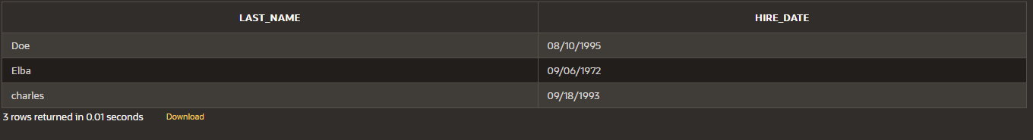

* 1. Create a report that displays the employee number, last name, and salary of all employees who earn more than the average salary. Sort the results in order of ascending salary.

SELECT EMPLOYEE_ID, LAST_NAME, SALARY

FROM employees WHERE SALARY > (

SELECT AVG(SALARY)

FROM employees

)

ORDER BY SALARY ASC;

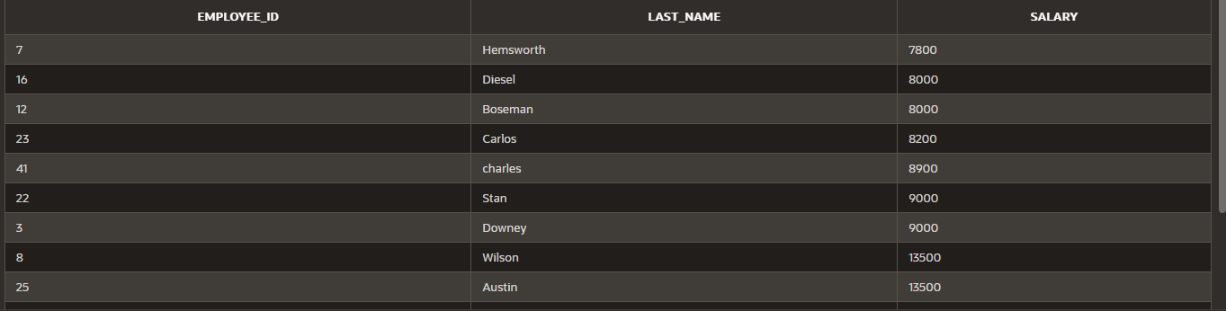

* 1. Write a query that displays the employee number and last name of all employees who work in a department with any employee whose last name contains a u.

SELECT EMPLOYEE_ID, LAST_NAME

FROM employees

WHERE DEPARTMENT_ID IN ( SELECT DEPARTMENT_ID

FROM employees

WHERE LAST_NAME LIKE '%a%' and LAST_NAME LIKE '%u%');

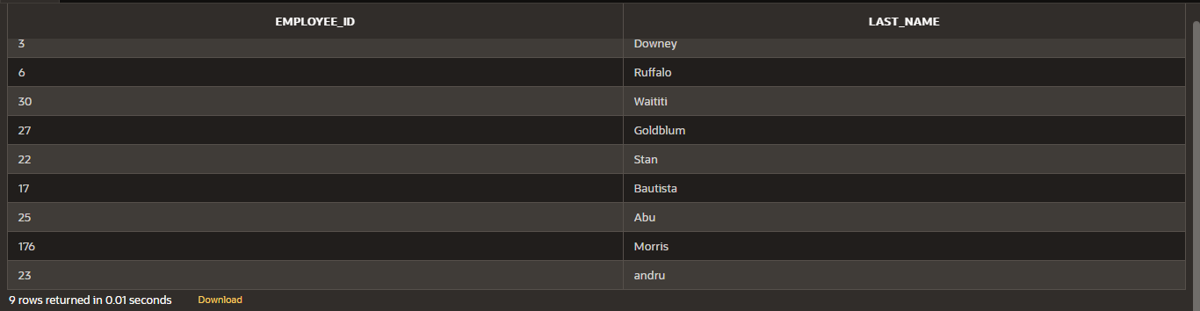

* 1. The HR department needs a report that displays the last name, department number, and job ID of all employees whose department location ID is 1700.

SELECT e.last_name, e.department_id, e.job_id

FROM employees e

INNER JOIN department d ON e.department_id = d.dept_id WHERE e.department_id IN (

SELECT dept_id FROM department

WHERE location_id = 1700);

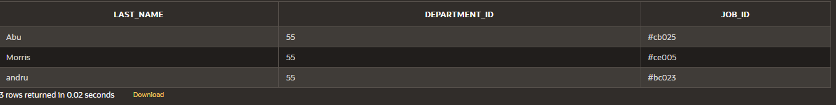

* 1. Create a report for HR that displays the last name and salary of every employee who reports to King.

SELECT e.last_name, e.salary FROM employees e

WHERE e.manager_id IN ( SELECT d.manager_id FROM department d

WHERE d.manager_name = 'king');

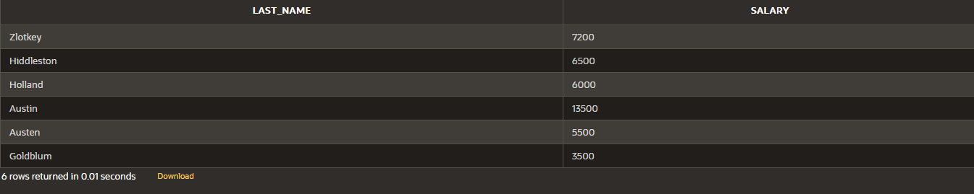

* 1. Create a report for HR that displays the department number, last name, and job ID for every employee in the Executive department.

SELECT e.department_id, e.last_name, e.job_id FROM employees e

JOIN department d on e.department_id = d.dept_id WHERE d.dept_name = 'executive';

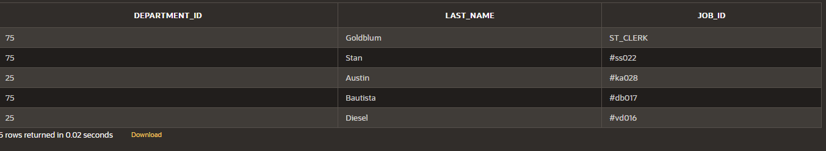

* 1. Modify the query 3 to display the employee number, last name, and salary of all employees who earn more than the average salary and who work in a department with any employee whose last name contains a u.

SELECT e.employee_id, e.last_name, e.salary FROM employees e

WHERE e.salary > ( SELECT AVG(salary) FROM employees

)

AND e.department_id IN ( SELECT x.department_id FROM employees x

WHERE x.last_name LIKE '%a%' AND x.last_name LIKE '%u%'

);

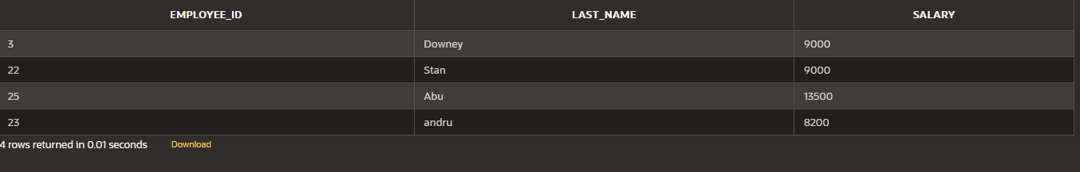

|  |  |  |
| --- | --- | --- |
| **Ex.No.: 10** | | **AGGREGATING DATA USING GROUP FUNCTIONS** |
| **Date:** | 12/09/2024 |

**Find the Solution for the following:**

Determine the validity of the following three statements. Circle either True or False.

1. Group functions work across many rows to produce one result per group. True/False - TRUE
2. Group functions include nulls in calculations. True/False - FALSE
3. The WHERE clause restricts rows prior to inclusion in a group calculation. True/False - FALSE
4. Find the highest, lowest, sum, and average salary of all employees. Label the columns Maximum, Minimum, Sum, and Average, respectively. Round your results to the nearest whole number

SELECT ROUND(MAX(salary)) AS Maximum, ROUND(MIN(salary)) AS Minimum, ROUND(SUM(salary)) AS Sum, ROUND(AVG(salary)) AS Average

FROM employees;



1. Modify the above query to display the minimum, maximum, sum, and average salary for each job type.

SELECT ROUND(MAX(salary)) AS Maximum, ROUND(MIN(salary)) AS Minimum, ROUND(SUM(salary)) AS Sum, ROUND(AVG(salary)) AS Average

FROM employees join department

on department.dept_id = employees.department_id group by dept_name;

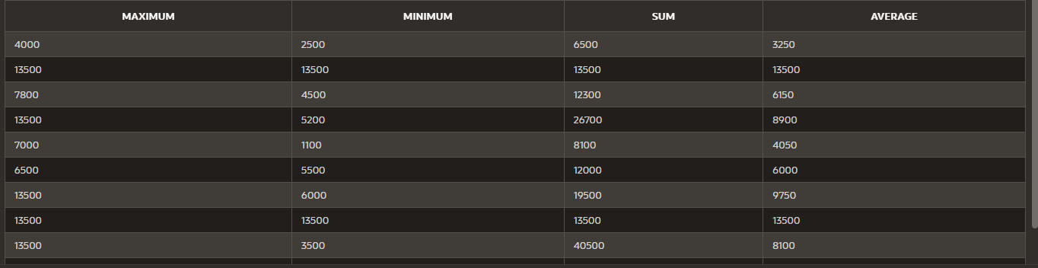

1. Write a query to display the number of people with the same job. Generalize the query so that

the user in the HR department is prompted for a job title.

SELECT d.dept_name , COUNT(*) AS NumberOfEmployees FROM Employees e

join department d on e.department_id = d.dept_id group by d.dept_name;

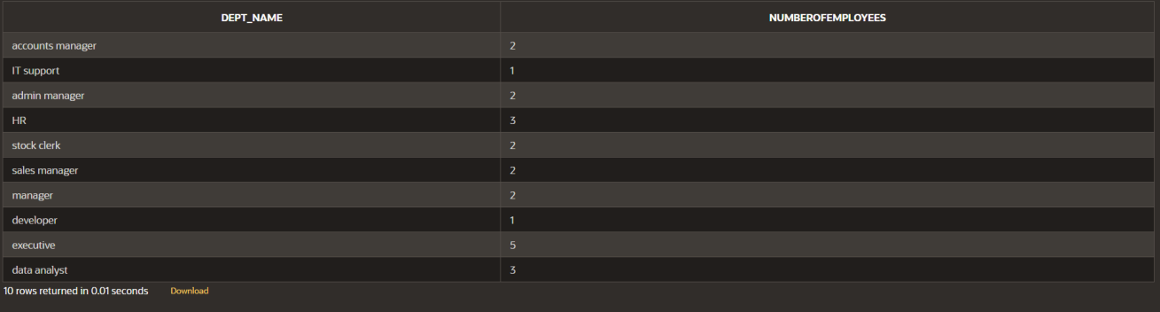

1. Determine the number of managers without listing them. Label the column Number of Managers

SELECT COUNT(DISTINCT MANAGER_ID) AS "Number of Managers"

FROM Employees

# WHERE MANAGER_ID IS NOT NULL;



1. Find the difference between the highest and lowest salaries. Label the column DIFFERENCE.

select max(salary) - min(salary) as "DIFFERENCE" from employees;



1. Create a report to display the manager number and the salary of the lowest-paid employee for that manager. Exclude anyone whose manager is not known. Exclude any groups where the minimum salary is $6,000 or less. Sort the output in descending order of salary.

SELECT MANAGER_ID, MIN(SALARY) AS "Lowest Salary"

FROM Employees

# WHERE MANAGER_ID IS NOT NULL GROUP BY MANAGER_ID

HAVING MIN(SALARY) > 6000

ORDER BY "Lowest Salary" DESC;

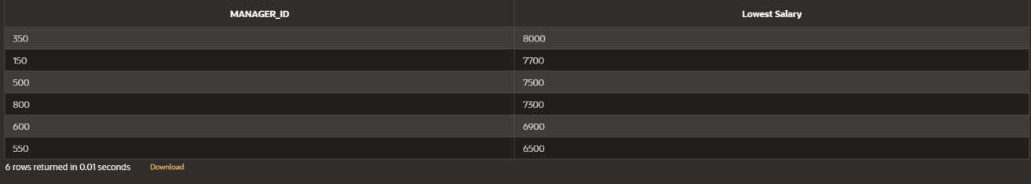

1. Create a query to display the total number of employees and, of that total, the number of employees hired in 1995, 1996, 1997, and 1998. Create appropriate column headings.

SELECT EXTRACT(YEAR FROM hire_date) AS "yearly wise employment", COUNT(*) FROM employees

GROUP BY EXTRACT(YEAR FROM hire_date)

HAVING EXTRACT(YEAR FROM hire_date) IN (1995, 1996, 1997, 1998);



1. Create a matrix query to display the job, the salary for that job based on department number, and the total salary for that job, for departments 20, 50, 80, and 90, giving each column an appropriate heading.

select d.dept_name , sum(e.salary) from employees e

join department d on e.department_id = d.dept_id where department_id in (20,50,80,90)

group by d.dept_name;



1. Write a query to display each department‘s name, location, number of employees, and the

average salary for all the employees in that department. Label the column name- Location,

Number of people, and salary respectively. Round the average salary to two decimal places.

SELECT d.dept_name AS "Name", d.Location_id AS "Location", COUNT(e.department_id) AS "Number of People", ROUND(AVG(e.Salary), 2) AS "Salary"

FROM department d

JOIN employees e ON d.dept_id = e.department_id

GROUP BY d.dept_name, d.location_id;

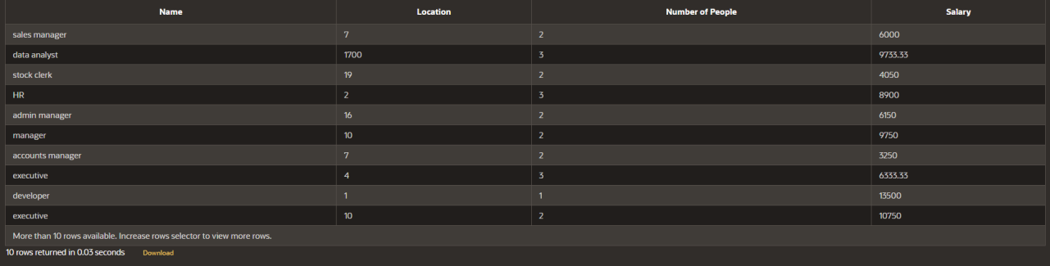

|  |  |  |
| --- | --- | --- |
| **Ex.No.: 11** | | **PL SQL PROGRAMS** |
| **Date:** | 13/09/2024 |

## PROGRAM 1

Write a PL/SQL block to calculate the incentive of an employee whose ID is 110.

DECLARE

pl_emp_id employees.employee_id%TYPE := 110; pl_salary employees.salary%TYPE;

pl_incentive NUMBER; BEGIN

SELECT salary INTO pl_salary FROM employees

WHERE employee_id = pl_emp_id;

pl_incentive := pl_salary * 0.10; UPDATE employees

SET incentive = pl_incentive WHERE employee_id = pl_emp_id;

DBMS_OUTPUT.PUT_LINE('Incentive for employee ID ' || pl_emp_id || ' is ' || pl_incentive);

COMMIT; END;

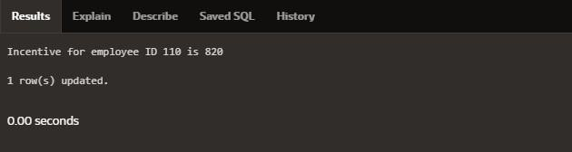

## PROGRAM 2

Write a PL/SQL block to show an invalid case-insensitive reference to a quoted and without quoted user-defined identifier.

DECLARE

employeeName VARCHAR2(100); "EmployeeID" NUMBER;

BEGIN

employeeName := 'John Doe'; "EmployeeID" := 40;

DBMS_OUTPUT.PUT_LINE('Employee Name: ' || employeeName); DBMS_OUTPUT.PUT_LINE('Employee ID: ' || "EmployeeID");

END;

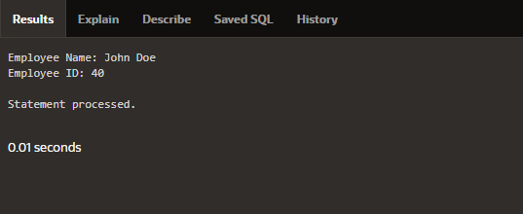

## PROGRAM 3

Write a PL/SQL block to adjust the salary of the employee whose ID 122. Sample table: employees

## DECLARE

v_employee_id NUMBER := 122; v_salary NUMBER; v_new_salary NUMBER;

v_increase_percentage NUMBER := 0.40; BEGIN

SELECT salary INTO v_salary FROM employees

WHERE employee_id = v_employee_id;

v_new_salary := v_salary + (v_salary * v_increase_percentage / 100); UPDATE employees

SET salary = v_new_salary

WHERE employee_id = v_employee_id;

DBMS_OUTPUT.PUT_LINE('Employee ID ' || v_employee_id || ' new salary: ' || v_new_salary);

## END;

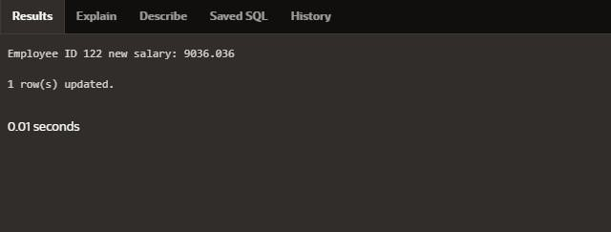

**PROGRAM 4**

Write a PL/SQL block to create a procedure using the "IS [NOT] NULL Operator" and show AND operator returns TRUE if and only if both operands are TRUE.

create or replace procedure check_null is

value1 number := 10; value2 number := null;

begin

if value1 is not null and value2 is null then dbms_output.put_line('Both values are not null!!');

else

dbms_output.put_line('Null value found'); end if;

end;

## BEGIN

check_null; END;

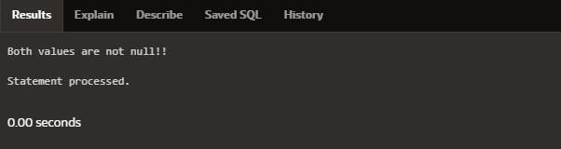

## PROGRAM 5

Write a PL/SQL block to describe the usage of LIKE operator including wildcard characters and

escape character.

declare

v_employeename employees.first_name%type; v_employeeid NUMBER := 122;

begin

select first_name into v_employeename from employees

where first_name like '%e%' and employee_id = v_employeeid; DBMS_OUTPUT.PUT_LINE(v_employeename);

## END;

**PROGRAM 6**

Write a PL/SQL program to arrange the number of two variable in such a way that the small number will store in num_small variable and large number will store in num_large variable.

declare

ab number :=10;

cd number :=20; num_small number; num_large number; begin

if ab>cd then num_small :=cd; num_large :=ab; else

num_small :=ab; num_large :=cd; end if;

dbms_output.put_line('small number = '||num_small); dbms_output.put_line('large number = '||num_large); End;

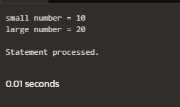

## PROGRAM 7

Write a PL/SQL procedure to calculate the incentive on a target achieved and display the message either the record updated or not.

create or replace procedure calculate_incentive(p_emp_id employees.employee_id%type, p_target number)

is

v_incentive number(7,2); v_salary employees.salary%type;

begin

select salary into v_salary from employees

where employee_id = p_emp_id;

if p_target >= 100000 then v_incentive := v_salary * 0.1;

dbms_output.put_line('Incentive of ' || v_incentive || ' calculated for employee ID ' || p_emp_id);

else

dbms_output.put_line('No incentive for employee ID ' || p_emp_id); end if;

End;

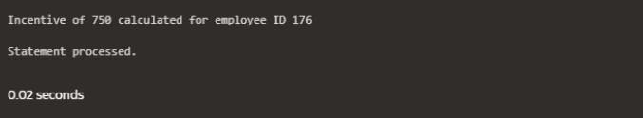

## PROGRAM 8

Write a PL/SQL procedure to calculate incentive achieved according to the specific sale limit.

create or replace procedure incentive_sale(p_emp_id employees.employee_id%type, p_sales number)

is

v_incentive number(7,2); begin

if p_sales > 100000 then v_incentive := p_sales * 0.1;

elsif p_sales between 50000 and 100000 then v_incentive := p_sales * 0.05;

else

v_incentive := 0; end if;

dbms_output.put_line('Incentive for employee ID ' || p_emp_id || ' is: ' || v_incentive); End;

begin

incentive_sale(122,500000); end;

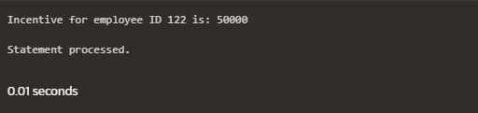

## PROGRAM 9

Write a PL/SQL program to count number of employees in department 50 and check whether this department have any vacancies or not. There are 45 vacancies in this department.

declare

no_of_emp number; vacancies number:=45; begin

select count(*) into no_of_emp from employees where department_id=50; if no_of_emp<vacancies then

dbms_output.put_line('vacancies are available'); else

dbms_output.put_line('vacancies are not available'); end if;

end;

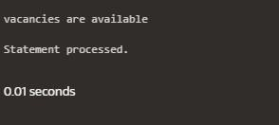

## PROGRAM 10

Write a PL/SQL program to count number of employees in a specific department and check whether this department have any vacancies or not. If any vacancies, how many vacancies are in that department.

declare

v_department_id number := 55; v_emp_count number; v_vacancies number := 50;

begin

select count(*) into v_emp_count from employees

where department_id = v_department_id;

if v_emp_count < v_vacancies then

dbms_output.put_line('Vacancies available: ' || (v_vacancies - v_emp_count)); else

dbms_output.put_line('No vacancies available.'); end if;

end;

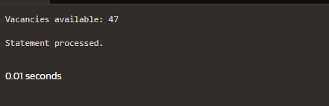

## PROGRAM 11

Write a PL/SQL program to display the employee IDs, names, job titles, hire dates, and salaries of all employees.

begin

for i in (select employee_id, first_name || ' ' || last_name as name, job_id, hire_date, salary from employees)

loop

dbms_output.put_line('ID: ' || i.employee_id || ', Name: ' || i.name || ', Job: ' || i.job_id

|| ', Hire Date: ' || i.hire_date || ', Salary: ' || i.salary); end loop;

end;

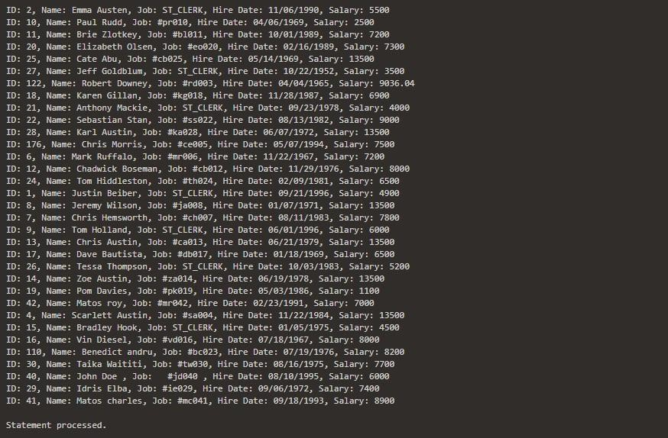

## PROGRAM 12

Write a PL/SQL program to display the employee IDs, names, and department names of all employees.

begin

for i in (select e.employee_id, e.first_name || ' ' || e.last_name as name, d.dept_name from employees e

join department d on e.employee_id = d.dept_id) loop dbms_output.put_line('ID: ' || i.employee_id || ', Name: ' || i.name || ', Department: ' ||

i.dept_name); end loop;

End;

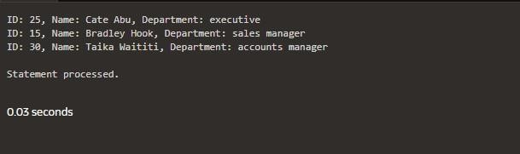

## PROGRAM 13

Write a PL/SQL program to display the job IDs, titles, and minimum salaries of all jobs.

begin

for rec in (select e.employee_id, d.dept_name, min(salary) as min_salary from employees

e join department d

on e.employee_ID = d.dept_id

group by e.employee_id , d.dept_name) loop

dbms_output.put_line('Job ID: ' || rec.employee_id || ', Title: ' || rec.dept_name || ', Min Salary: ' || rec.min_salary);

end loop; End;

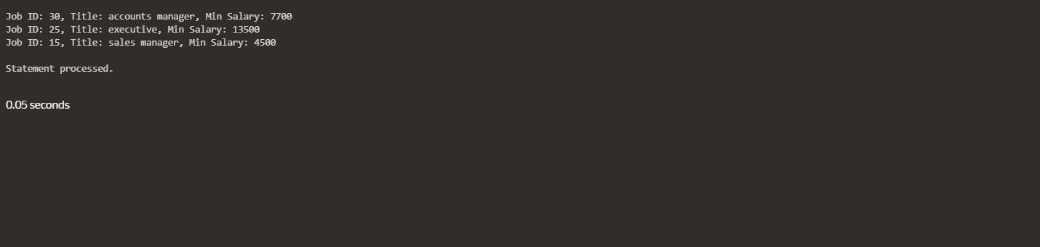

Write a PL/SQL program to display the job IDs, titles, and minimum salaries of all jobs.

begin

for rec in (select e.employee_id, d.dept_name, min(salary) as min_salary from employees

e join department d

on e.employee_ID = d.dept_id

group by e.employee_id , d.dept_name) loop

dbms_output.put_line('Job ID: ' || rec.employee_id || ', Title: ' || rec.dept_name || ', Min Salary: ' || rec.min_salary);

end loop; End;



## PROGRAM 14

Write a PL/SQL program to display the employee IDs, names, and job history start dates of all

Employees.

Begin

for rec in (select employee_id, first_name || ' ' || last_name as name, hire_date from employees) loop

dbms_output.put_line('ID: ' || rec.employee_id || ', Name: ' || rec.name || ', Start Date: '

|| rec.hire_date); end loop;

end;

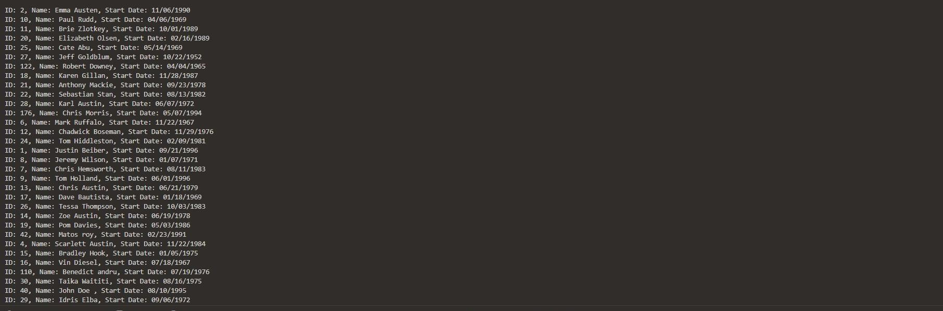

## PROGRAM 15

Write a PL/SQL program to display the employee IDs, names, and job history end datesof all employees.

## BEGIN

FOR rec IN (SELECT employee_id, first_name || ' ' || last_name AS name, end_date FROM employees)

## LOOP

dbms_output.put_line('ID: ' || rec.employee_id || ', Name: ' || rec.name ||

', End Date: ' ||

NVL(TO_CHAR(rec.end_date, 'YYYY-MM-DD'), 'Still Active'));

**END LOOP; END;**

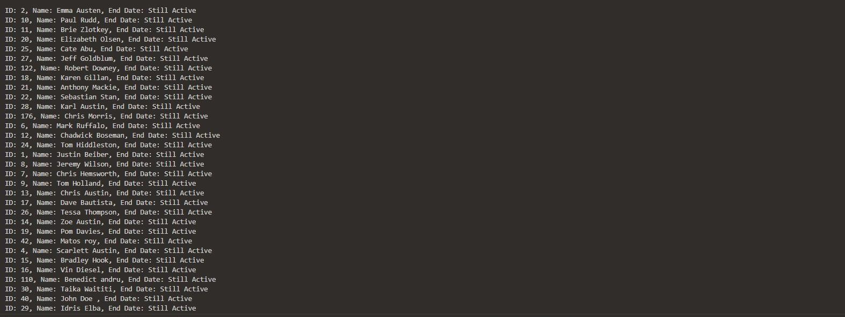

|  |  |  |
| --- | --- | --- |
| **Ex.No.: 12** | | **PL SQL PROGRAMS** |
| **Date:** | 19/09/2024 |

**Program 1**

**FACTORIAL OF A NUMBER USING FUNCTION**

## DECLARE

n NUMBER := 10;

result NUMBER;

FUNCTION itfact(num NUMBER) RETURN NUMBER IS fact NUMBER := 1;

## BEGIN

FOR i IN 1..num LOOP

fact := fact * i;

## END LOOP;

RETURN fact; END;

## BEGIN

result := itfact(n);

DBMS_OUTPUT.PUT_LINE('The factorial of ' || n || ' is ' || result); END;

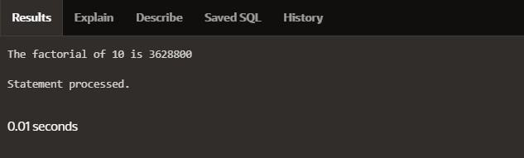

Program 2

Write a PL/SQL program using Procedures IN,INOUT,OUT parameters to retrieve the corresponding book information in library

CREATE OR REPLACE PROCEDURE book_info(

p_book_id IN NUMBER, p_author OUT VARCHAR2, p_title OUT VARCHAR2, p_published_date OUT DATE

## ) AS BEGIN

SELECT author, title, published_date INTO p_author, p_title, p_published_date FROM books

WHERE book_id = p_book_id;

## EXCEPTION

**WHEN NO_DATA_FOUND THEN**

p_author := NULL; p_title := NULL;

p_published_date := NULL; WHEN OTHERS THEN

## RAISE;

END book_info;

## DECLARE

v_author VARCHAR2(100); v_title VARCHAR2(100); v_published_date DATE; v_book_id NUMBER := 1;

## BEGIN

book_info(v_book_id, v_author, v_title, v_published_date);

IF v_author IS NOT NULL THEN DBMS_OUTPUT.PUT_LINE('Book ID: ' || v_book_id); DBMS_OUTPUT.PUT_LINE('Author: ' || v_author); DBMS_OUTPUT.PUT_LINE('Title: ' || v_title);

DBMS_OUTPUT.PUT_LINE('Published Date: ' || TO_CHAR(v_published_date, 'YYYY- MM-DD'));

## ELSE

DBMS_OUTPUT.PUT_LINE('No book found with ID: ' || v_book_id); END IF;

## END;

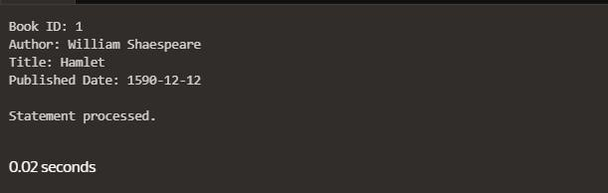

|  |  |  |
| --- | --- | --- |
| **Ex.No.: 13** | | **WORKING WITH TRIGGERS** |
| **Date:** | 20/09/2024 |

Program 1

Write a code in PL/SQL to develop a trigger that enforces referential integrity by preventing the deletion of a parent record if child records exist.

CREATE OR REPLACE TRIGGER prevent_parent_deletion BEFORE DELETE ON employees

## FOR EACH ROW DECLARE

pl_dept_count NUMBER; BEGIN

## SELECT COUNT(*)

INTO pl_dept_count FROM department

WHERE dept_id = :OLD.employee_id; IF pl_dept_count > 0 THEN

RAISE_APPLICATION_ERROR(-20001, 'Cannot delete employee record as department records exist.');

## END IF;

**END;**

DELETE FROM employees WHERE employee_id = 70;

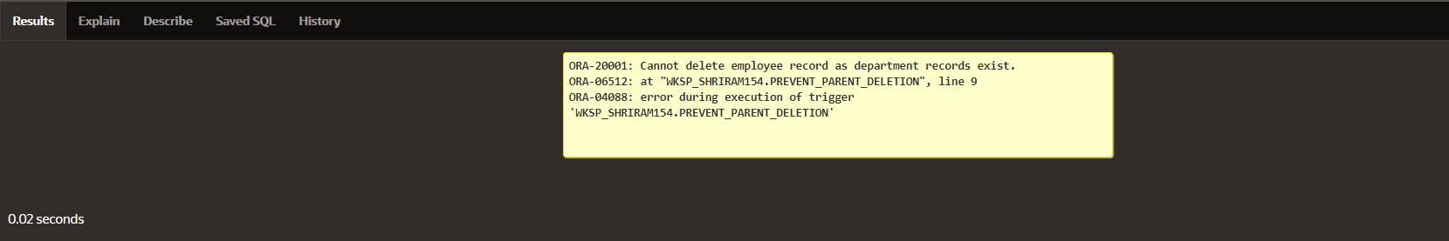

Program 2

Write a code in PL/SQL to create a trigger that checks for duplicate values in a specific column and raises an exception if found.

CREATE OR REPLACE TRIGGER prevent_duplicate_manager_id BEFORE INSERT OR UPDATE ON employees

## FOR EACH ROW DECLARE

pl_count NUMBER; BEGIN

## SELECT COUNT(*)

INTO pl_count FROM employees

WHERE manager_id = :NEW.manager_id AND employee_id != :NEW.employee_id; IF pl_count > 0 THEN

RAISE_APPLICATION_ERROR(-20003, 'Duplicate manager_id found: ' ||

:NEW.manager_id);

## END IF;

**END;**

INSERT INTO employees (employee_id, first_name, last_name, email, phone_number, hire_date, job_id, salary, commission_pct, manager_id, department_id)

VALUES (202, 'Jane', 'Smith', 'john006@gmail.com',7383922241,'11/9/2000','ST_CLERK',10000,0.15,400,80);

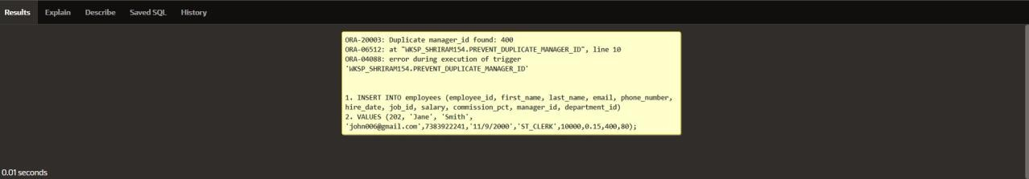

Program 3

Write a code in PL/SQL to create a trigger that restricts the insertion of new rows if the total of a

column's values exceeds a certain threshold.

CREATE OR REPLACE TRIGGER restrict_salary_insertion BEFORE INSERT ON employees

## FOR EACH ROW DECLARE

total_salary NUMBER; threshold NUMBER := 100000;

## BEGIN

SELECT SUM(salary) INTO total_salary FROM employees;

IF (total_salary + :NEW.salary) > threshold THEN

RAISE_APPLICATION_ERROR(-20004, 'Insertion denied: Total salary exceeds the threshold of ' || threshold);

## END IF;

**END;**

INSERT INTO employees (employee_id, first_name, last_name, email, phone_number, hire_date, job_id, salary, commission_pct, manager_id, department_id)

VALUES (203, 'Charlie', 'Brown', 'charlie203@gmail.com', '9122334455','03/01/2021', '#cb203', 5000, 0.20, 1000, 50);

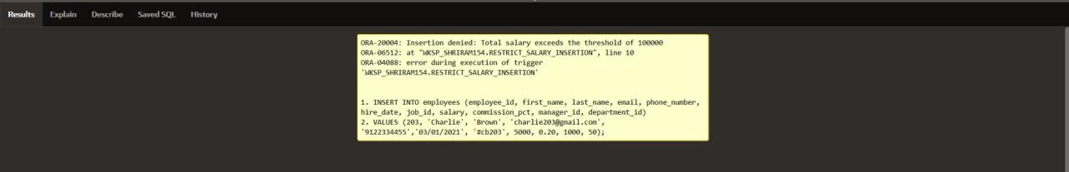

## PROGRAM 4

Write a code in PL/SQL to design a trigger that captures changes made to specific columns and logs them in an audit table.

CREATE OR REPLACE TRIGGER audit_changes AFTER UPDATE OF salary, job_id ON employees FOR EACH ROW

## BEGIN

IF :OLD.salary != :NEW.salary OR :OLD.job_id != :NEW.job_id THEN INSERT INTO employee_audit (

employee_id, old_salary, new_salary, old_job_title, new_job_title, change_timestamp, changed_by

## ) VALUES (

:OLD.employee_id,

:OLD.salary,

:NEW.salary,

:OLD.job_id,

:NEW.job_id, SYSTIMESTAMP, USER

## ); END IF;

**END;**

UPDATE employees

SET salary = 55000, job_id = 'ST_CLERK' WHERE employee_id = 176;

SELECT * FROM employee_audit;

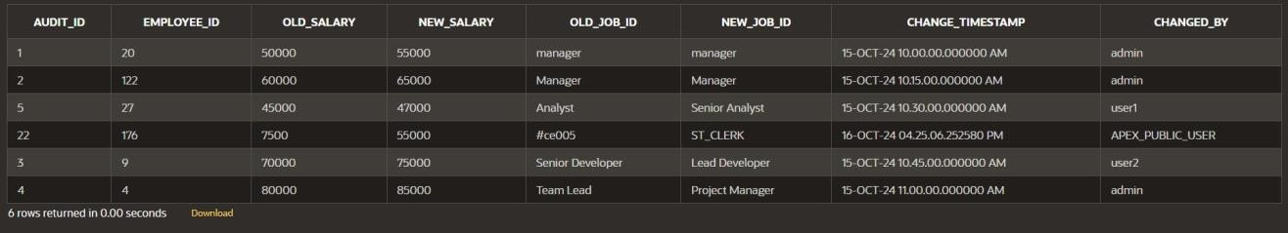

## PROGRAM 5

Write a code in PL/SQL to implement a trigger that records user activity (inserts, updates, deletes) in an audit log for a given set of tables.

CREATE OR REPLACE TRIGGER trg_audit_employees AFTER INSERT OR UPDATE OR DELETE ON employees FOR EACH ROW

## DECLARE

v_old_values CLOB; v_new_values CLOB;

## BEGIN

**IF INSERTING THEN**

v_old_values := NULL;

v_new_values := 'employee_id: ' || :NEW.employee_id || ', ' || 'first_name: ' || :NEW.first_name || ', ' ||

'salary: ' || :NEW.salary;

INSERT INTO audit_log (action, table_name, record_id, changed_by, new_values) VALUES ('INSERT', 'employees', :NEW.employee_id, USER, v_new_values);

## ELSIF UPDATING THEN

v_old_values := 'employee_id: ' || :OLD.employee_id || ', ' || 'first_name: ' || :OLD.first_name || ', ' ||

'salary: ' || :OLD.salary;

v_new_values := 'employee_id: ' || :NEW.employee_id || ', ' || 'first_name: ' || :NEW.first_name || ', ' ||

'salary: ' || :NEW.salary;

INSERT INTO audit_log (action, table_name, record_id, changed_by, old_values, new_values)

VALUES ('UPDATE', 'employees', :NEW.employee_id, USER, v_old_values, v_new_values);

## ELSIF DELETING THEN

v_old_values := 'employee_id: ' || :OLD.employee_id || ', ' || 'first_name: ' || :OLD.first_name || ', ' ||

'salary: ' || :OLD.salary; v_new_values := NULL;

INSERT INTO audit_log (action, table_name, record_id, changed_by, old_values) VALUES ('DELETE', 'employees', :OLD.employee_id, USER, v_old_values);

## END IF;

END trg_audit_employees;

INSERT INTO employees (employee_id, first_name, salary) VALUES (3, 'Ball', 50000);

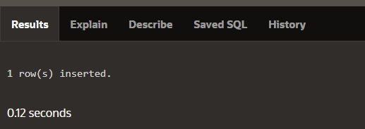

UPDATE employees SET salary = 55000

WHERE employee_id = 3;

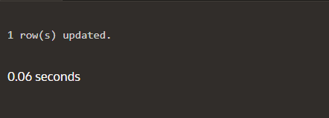

DELETE FROM employees WHERE employee_id = 3;

SELECT * FROM audit_log;

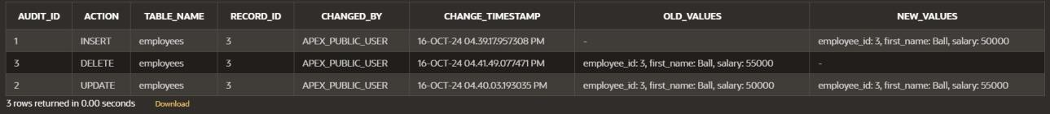

## PROGRAM 6

Write a code in PL/SQL to implement a trigger that automatically calculates and updates a running total column for a table whenever new rows are inserted.

CREATE TABLE transactions ( transaction_id NUMBER PRIMARY KEY, amount NUMBER,

running_total NUMBER

**);**

CREATE OR REPLACE TRIGGER update_running_total FOR INSERT ON transactions

## COMPOUND TRIGGER

TYPE amount_array IS TABLE OF NUMBER INDEX BY PLS_INTEGER;

new_amounts amount_array;

## BEFORE EACH ROW IS BEGIN

new_amounts(:NEW.transaction_id) := :NEW.amount; END BEFORE EACH ROW;

## AFTER STATEMENT IS BEGIN

**DECLARE**

v_total NUMBER; BEGIN

SELECT NVL(MAX(running_total), 0) INTO v_total

FROM transactions;

FOR i IN new_amounts.FIRST .. new_amounts.LAST LOOP v_total := v_total + new_amounts(i);

UPDATE transactions

SET running_total = v_total WHERE transaction_id = i;

## END LOOP; END;

**END AFTER STATEMENT;**

END update_running_total;

INSERT INTO transactions (transaction_id, amount)

## VALUES (1, 10000);

INSERT INTO transactions (transaction_id, amount) VALUES (2, 20000);

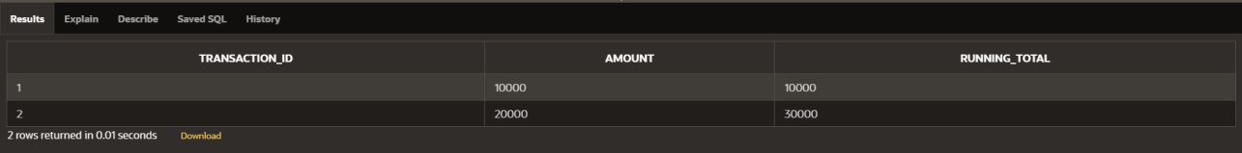

## PROGRAM 7

Write a code in PL/SQL to create a trigger that validates the availability of items before allowing an order to be placed, considering stock levels and pending orders.

CREATE TABLE inventory ( item_id NUMBER PRIMARY KEY,

item_name VARCHAR2(100), stock_level NUMBER

**);**

CREATE TABLE orders (

order_id NUMBER PRIMARY KEY, item_id NUMBER,

quantity NUMBER, order_status VARCHAR2(20),

CONSTRAINT fk_item FOREIGN KEY (item_id) REFERENCES inventory(item_id)

**);**

CREATE OR REPLACE TRIGGER validate_stock_before_order BEFORE INSERT ON orders

## FOR EACH ROW DECLARE

v_stock_level NUMBER; v_pending_orders NUMBER;

## BEGIN

SELECT stock_level INTO v_stock_level FROM inventory

WHERE item_id = :NEW.item_id; SELECT NVL(SUM(quantity), 0) INTO v_pending_orders

FROM orders

WHERE item_id = :NEW.item_id AND order_status = 'Pending';

IF (:NEW.quantity + v_pending_orders) > v_stock_level THEN RAISE_APPLICATION_ERROR(-20001, 'Insufficient stock for item: ' || :NEW.item_id);

## END IF;

**END;**

INSERT INTO orders (order_id, item_id, quantity, order_status) VALUES (1, 101, 5, 'Pending');

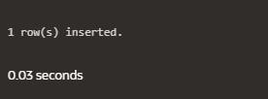

INSERT INTO orders (order_id, item_id, quantity, order_status) VALUES (2, 103, 20, 'Pending');

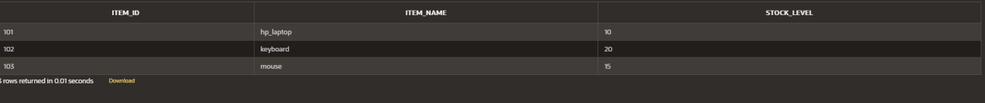



|  |  |  |
| --- | --- | --- |
| **Ex.No.: 14** | | **MONGO DB** |
| **Date:** | 26/09/2024 |

1. **Write a MongoDB query to find the restaurant Id, name, borough and cuisine for those restaurants which prepared dish except 'American' and 'Chinees' or restaurant's name begins with letter 'Wil'.**

db.restaurants.find(

**{**

$or: [

{ cuisine: { $nin: ["American", "Chinees"] } },

{ name: { $regex: /^Wil/i } }

**]**

**},**

**{**

restaurant_id: 1,

name: 1,

borough: 1,

cuisine: 1,

_id: 0

**}**

**);**

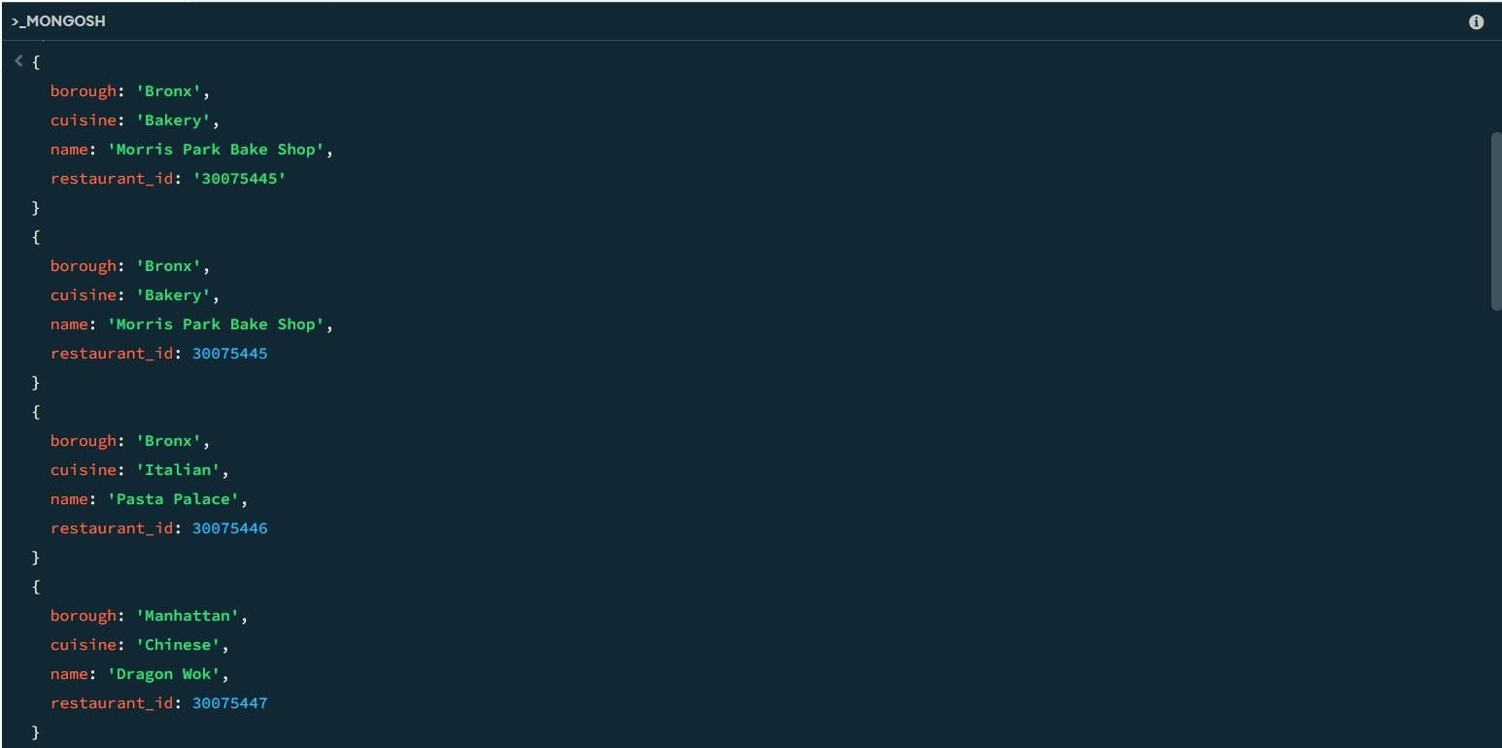

1. **Write a MongoDB query to find the restaurant Id, name, and grades for those restaurants which achieved a grade of "A" and scored 11 on an ISODate "2014-08- 11T00:00:00Z" among many of survey dates..**

db.restaurants.find(

**{**

grades: {

$elemMatch: { grade: "A", score: 11

**}**

**}**

**},**

**{**

restaurant_id: 1,

name: 1,

grades: 1,

_id: 0

**}**

**);**

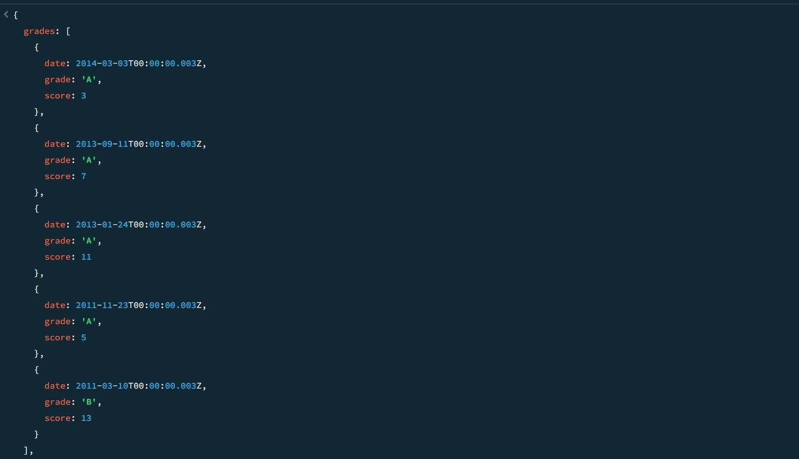

1. **Write a MongoDB query to find the restaurant Id, name and grades for those restaurants where the 2nd element of grades array contains a grade of "A" and score 9 on an ISODate "2014-08-11T00:00:00Z".**

db.restaurants.find(

**{**

"grades.1": {

$elemMatch: { grade: "A", score: 9

**}**

**}**

**},**

**{**

restaurant_id: 1,

name: 1,

grades: 1,

_id: 0

**}**

**);**

1. **Write a MongoDB query to find the restaurant Id, name, address and geographical location for those restaurants where 2nd element of coord array contains a value which is more than 42 and upto 52..**

db.restaurants.find(

**{**

"address.coord.1": { $gt: 42, $lte: 52 }

**},**

**{**

restaurant_id: 1,

name: 1,

address: 1,

_id: 0

**}**

**);**

1. **Write a MongoDB query to arrange the name of the restaurants in ascending order along with all the columns.**

db.restaurants.find().sort({ name: 1 }); SAMPLE OUTPUT:-

**{**

_id: ObjectId('671b5e6d56ec9972ca8f5dc4'), address: {

building: 5566, coord: [

-73.867377,

40.854047

**],**

street: '28th Avenue', zipcode: 10490

**},**

borough: 'Bronx', cuisine: 'BBQ', grades: [

**{**

date: 2014-03-03T00:00:00.028Z,

grade: 'A', score: 10

**},**

**{**

date: 2013-09-11T00:00:00.028Z,

grade: 'A', score: 7

**},**

**{**

date: 2013-01-24T00:00:00.028Z,

grade: 'A', score: 11

**},**

**{**

date: 2011-11-23T00:00:00.028Z,

grade: 'A', score: 9

**},**

**{**

date: 2011-03-10T00:00:00.028Z,

grade: 'B',

score: 15

**}**

**],**

name: 'BBQ Haven', restaurant_id: 30075473

**}**

**{**

_id: ObjectId('671b5dab56ec9972ca8f5db0'), address: {

building: 5566, coord: [

-73.859377,

40.850047

**],**

street: '8th Avenue', zipcode: 10470

**},**

borough: 'Manhattan', cuisine: 'French', grades: [

**{**

date: 2014-03-03T00:00:00.008Z,

grade: 'A', score: 7

**},**

**{**

date: 2013-09-11T00:00:00.008Z,

grade: 'A', score: 9

**},**

**{**

date: 2013-01-24T00:00:00.008Z,

grade: 'A', score: 10

**},**

**{**

date: 2011-11-23T00:00:00.008Z,

grade: 'B', score: 15

**},**

**{**

date: 2011-03-10T00:00:00.008Z,

grade: 'A', score: 6

**}**

**],**

name: 'Bistro Belle', restaurant_id: 30075453

**}**

1. **Write a MongoDB query to arrange the name of the restaurants in descending along with all the columns.**

db.restaurants.find().sort({ name: -1 });

**SAMPLE OUTPUT**

**{**

_id: ObjectId('671b5e9456ec9972ca8f5dc8'), address: {

building: 9900, coord: [

-73.868977,

40.854847

**],**

street: '32nd Avenue', zipcode: 10494

**},**

borough: 'Manhattan', cuisine: 'Russian', grades: [

**{**

date: 2014-03-03T00:00:00.032Z,

grade: 'A', score: 10

**},**

**{**

date: 2013-09-11T00:00:00.032Z,

grade: 'B', score: 5

**},**

**{**

date: 2013-01-24T00:00:00.032Z,

grade: 'A', score: 9

**},**

**{**

date: 2011-11-23T00:00:00.032Z,

grade: 'A', score: 8

**},**

**{**

date: 2011-03-10T00:00:00.032Z,

grade: 'A', score: 11

**}**

**],**

name: "Tsar's Table", restaurant_id: 30075477

**}**

**{**

_id: ObjectId('671b5e6d56ec9972ca8f5dbe'), address: {

building: 9900, coord: [

-73.864977,

40.852847

**],**

street: '22nd Avenue', zipcode: 10484

**},**

borough: 'Bronx', cuisine: 'Italian', grades: [

**{**

date: 2014-03-03T00:00:00.022Z,

grade: 'A', score: 8

**},**

**{**

date: 2013-09-11T00:00:00.022Z,

grade: 'B', score: 5

**},**

**{**

date: 2013-01-24T00:00:00.022Z,

grade: 'A', score: 12

**},**

**{**

date: 2011-11-23T00:00:00.022Z,

grade: 'A', score: 9

**},**

**{**

date: 2011-03-10T00:00:00.022Z,

grade: 'A', score: 14

**}**

**],**

name: 'Trattoria Bella', restaurant_id: 30075467

**}**

1. **Write a MongoDB query to arrange the name of the cuisine in ascending order and for that same cuisine borough should be in descending order.**

db.restaurants.find().sort({ cuisine: 1, borough: -1 }); SAMPLE OUTPUT:-

**{**

_id: ObjectId('671b5d549d3d63480e0a64e9'), address: {

building: 2233, coord: [

-73.858177,

40.849447

**],**

street: '5th Avenue', zipcode: 10467

**},**

borough: 'Bronx', cuisine: 'American',

grades: [

**{**

date: 2014-03-03T00:00:00.005Z,

grade: 'A', score: 10

**},**

**{**

date: 2013-09-11T00:00:00.005Z,

grade: 'A', score: 6

**},**

**{**

date: 2013-01-24T00:00:00.005Z,

grade: 'B', score: 12

**},**

**{**

date: 2011-11-23T00:00:00.005Z,

grade: 'A', score: 9

**},**

**{**

date: 2011-03-10T00:00:00.005Z,

grade: 'A', score: 14

**}**

**],**

name: 'Burger Bistro', restaurant_id: 30075450

**}**

**{**

_id: ObjectId('671b5e6d56ec9972ca8f5dc4'), address: {

building: 5566, coord: [

-73.867377,

40.854047

**],**

street: '28th Avenue', zipcode: 10490

**},**

borough: 'Bronx', cuisine: 'BBQ',

grades: [

**{**

date: 2014-03-03T00:00:00.028Z,

grade: 'A', score: 10

**},**

**{**

date: 2013-09-11T00:00:00.028Z,

grade: 'A', score: 7

**},**

**{**

date: 2013-01-24T00:00:00.028Z,

grade: 'A', score: 11

**},**

**{**

date: 2011-11-23T00:00:00.028Z,

grade: 'A', score: 9

**},**

**{**

date: 2011-03-10T00:00:00.028Z,

grade: 'B', score: 15

**}**

**],**

name: 'BBQ Haven', restaurant_id: 30075473

**}**

1. **Write a MongoDB query to know whether all the addresses contains the street or not.**

db.restaurants.find(

**{**

"address.street": { $exists: false }

**}**

**);**

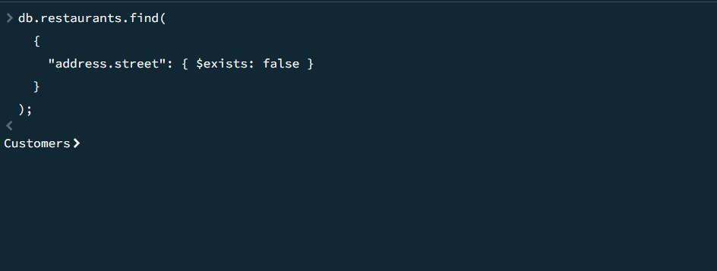

1. **Write a MongoDB query which will select all documents in the restaurants collection where the coord field value is Double.**

db.restaurants.find(

**{**

"address.coord": { $type: "double" }

**}**

**);**

**SAMPLE OUTPUT:-**

**{**

_id: ObjectId('671b92d339ec8a9bc8b6588b'), address: {

building: '1007', coord: [

-73.856077,

40.848447

**],**

street: 'Morris Park Ave', zipcode: '10462'

**},**

borough: 'Bronx', cuisine: 'Bakery', grades: [

**{**

date: 2014-03-03T00:00:00.000Z,

grade: 'A', score: 2

**},**

**{**

date: 2013-09-11T00:00:00.000Z,

grade: 'A', score: 6

**},**

**{**

date: 2013-01-24T00:00:00.000Z,

grade: 'A', score: 10

**},**

**{**

date: 2011-11-23T00:00:00.000Z,

grade: 'A', score: 9

**},**

**{**

date: 2011-03-10T00:00:00.000Z,

grade: 'B', score: 14

**}**

**],**

name: 'Morris Park Bake Shop', restaurant_id: '30075445'

**}**

**{**

_id: ObjectId('671b5d549d3d63480e0a64e5'), address: {

building: 1234, coord: [

-73.856577,

40.848647

**],**

street: '1st Avenue', zipcode: 10463

**},**

borough: 'Bronx', cuisine: 'Italian', grades: [

**{**

date: 2014-03-03T00:00:00.001Z,

grade: 'A', score: 5

**},**

**{**

date: 2013-09-11T00:00:00.001Z,

grade: 'A', score: 8

**},**

**{**

date: 2013-01-24T00:00:00.001Z,

grade: 'B', score: 12

**},**

**{**

date: 2011-11-23T00:00:00.001Z,

grade: 'A', score: 7

**},**

**{**

date: 2011-03-10T00:00:00.001Z,

grade: 'A', score: 15

**}**

**],**

name: 'Pasta Palace', restaurant_id: 30075446

**}**

1. **Write a MongoDB query which will select the restaurant Id, name and grades for those**

restaurants which returns 0 as a remainder after dividing the score by 7.

db.restaurants.find(

**{**

"grades.score": { $mod: [7, 0] }

**},**

**{**

restaurant_id: 1,

name: 1,

grades: 1,

_id: 0

**}**

**);**

**SAMPLE OUTPUT:-**

**{**

grades: [

**{**

date: 2014-03-03T00:00:00.000Z,

grade: 'A', score: 2

**},**

**{**

date: 2013-09-11T00:00:00.000Z,

grade: 'A', score: 6

**},**

**{**

date: 2013-01-24T00:00:00.000Z,

grade: 'A', score: 10

**},**

**{**

date: 2011-11-23T00:00:00.000Z,

grade: 'A', score: 9

**},**

**{**

date: 2011-03-10T00:00:00.000Z,

grade: 'B', score: 14

**}**

**],**

name: 'Morris Park Bake Shop', restaurant_id: '30075445'

**}**

**{**

grades: [

**{**

date: 2014-03-03T00:00:00.001Z,

grade: 'A', score: 5

**},**

**{**

date: 2013-09-11T00:00:00.001Z,

grade: 'A', score: 8

**},**

**{**

date: 2013-01-24T00:00:00.001Z,

grade: 'B', score: 12

**},**

**{**

date: 2011-11-23T00:00:00.001Z,

grade: 'A', score: 7

**},**

**{**

date: 2011-03-10T00:00:00.001Z,

grade: 'A', score: 15

**}**

**],**

name: 'Pasta Palace', restaurant_id: 30075446

**}**

1. **Write a MongoDB query to find the restaurant name, borough, longitude and attitude and cuisine for those restaurants which contains 'mon' as three letters somewhere in its name.**

db.restaurants.find(

**{**

name: { $regex: /mon/i }

**},**

**{**

name: 1,

borough: 1,

"address.coord.0": 1, // Longitude "address.coord.1": 1, // Latitude cuisine: 1,

_id: 0

**}**

**);**

1. **Write a MongoDB query to find the restaurant name, borough, longitude and latitude and cuisine for those restaurants which contain 'Mad' as first three letters of its name.**

db.restaurants.find(

**{**

name: { $regex: /^Mad/i }

**},**

**{**

name: 1,

borough: 1,

"address.coord.0": 1, // Longitude "address.coord.1": 1, // Latitude cuisine: 1,

_id: 0

**}**

**);**

1. **Write a MongoDB query to find the restaurants that have at least one grade with a score of less than 5.**

db.restaurants.find(

**{**

"grades.score": { $lt: 5 }

**}**

**);**

**SAMPLE OUTPUT:-**

**{**

_id: ObjectId('671b92d339ec8a9bc8b6588b'), address: {

building: '1007',

coord: [

-73.856077,

40.848447

**],**

street: 'Morris Park Ave', zipcode: '10462'

**},**

borough: 'Bronx', cuisine: 'Bakery', grades: [

**{**

date: 2014-03-03T00:00:00.000Z,

grade: 'A', score: 2

**},**

**{**

date: 2013-09-11T00:00:00.000Z,

grade: 'A', score: 6

**},**

**{**

date: 2013-01-24T00:00:00.000Z,

grade: 'A', score: 10

**},**

**{**

date: 2011-11-23T00:00:00.000Z,

grade: 'A', score: 9

**},**

**{**

date: 2011-03-10T00:00:00.000Z,

grade: 'B', score: 14

**}**

**],**

name: 'Morris Park Bake Shop', restaurant_id: '30075445'

**}**

**{**

_id: ObjectId('671b5d549d3d63480e0a64e6'), address: {

building: 5678, coord: [

-73.856977,

40.848847

**],**

street: '2nd Avenue', zipcode: 10464

**},**

borough: 'Manhattan', cuisine: 'Chinese', grades: [

**{**

date: 2014-03-03T00:00:00.002Z,

grade: 'B', score: 4

**},**

**{**

date: 2013-09-11T00:00:00.002Z,

grade: 'A', score: 9

**},**

**{**

date: 2013-01-24T00:00:00.002Z,

grade: 'A', score: 10

**},**

**{**

date: 2011-11-23T00:00:00.002Z,

grade: 'A', score: 8

**},**

**{**

date: 2011-03-10T00:00:00.002Z,

grade: 'B', score: 16

**}**

**],**

name: 'Dragon Wok', restaurant_id: 30075447

**}**

1. **Write a MongoDB query to find the restaurants that have at least one grade with a score of less than 5 and that are located in the borough of Manhattan.**

db.restaurants.find(

**{**

"grades.score": { $lt: 5 }, borough: "Manhattan"

**}**

**);**

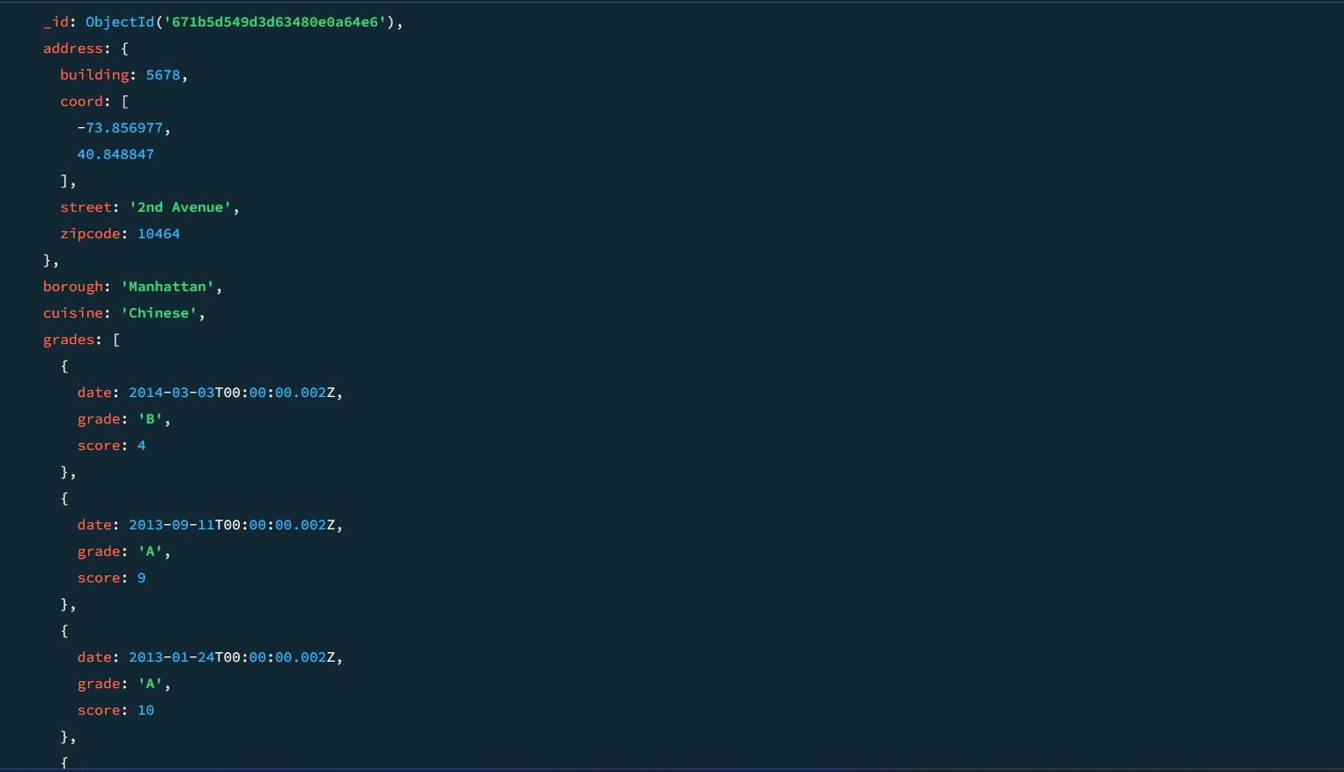

1. **Write a MongoDB query to find the restaurants that have at least one grade with a score of less than 5 and that are located in the borough of Manhattan or Brooklyn.**

db.restaurants.find(

**{**

"grades.score": { $lt: 5 },

borough: { $in: ["Manhattan", "Brooklyn"] }

**}**

**);**

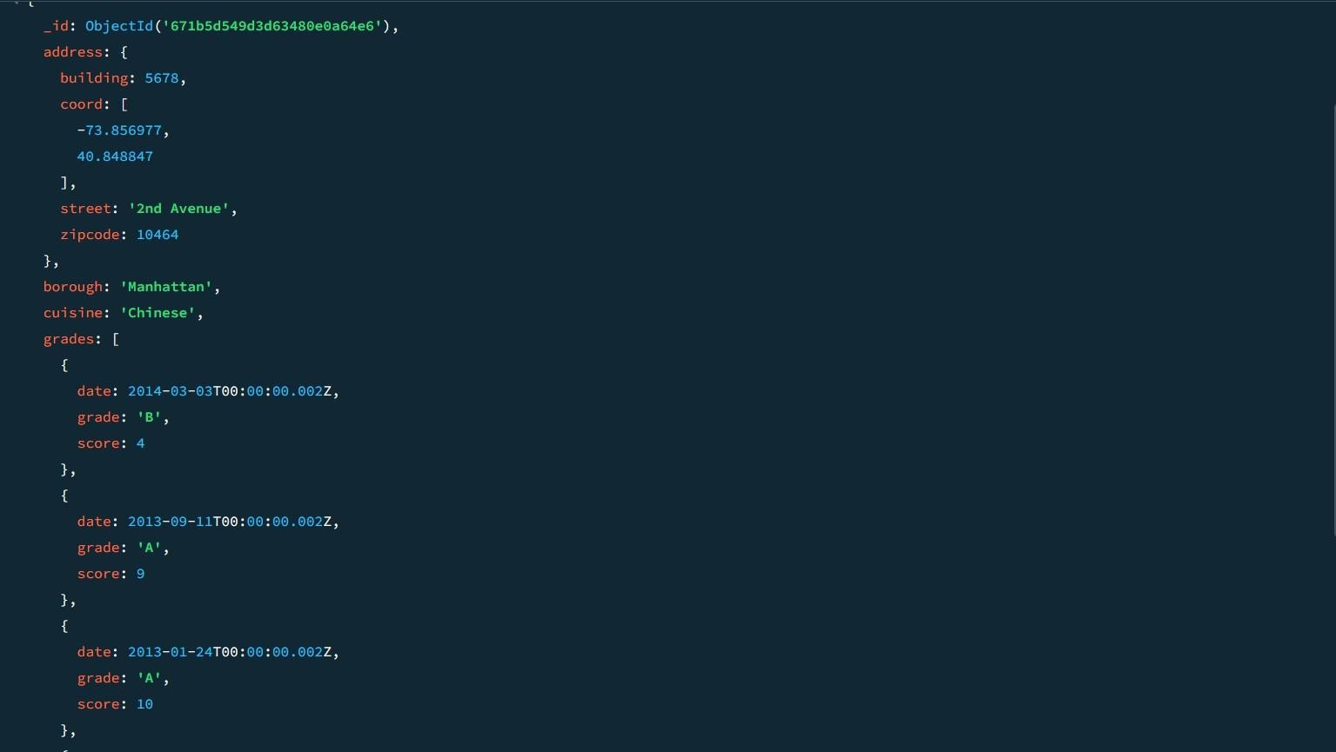

1. **Write a MongoDB query to find the restaurants that have at least one grade with a score of less than 5 and that are located in the borough of Manhattan or Brooklyn, and their cuisine is not American.**

db.restaurants.find(

**{**

"grades.score": { $lt: 5 },

borough: { $in: ["Manhattan", "Brooklyn"] }, cuisine: { $ne: "American" }

**}**

**);**

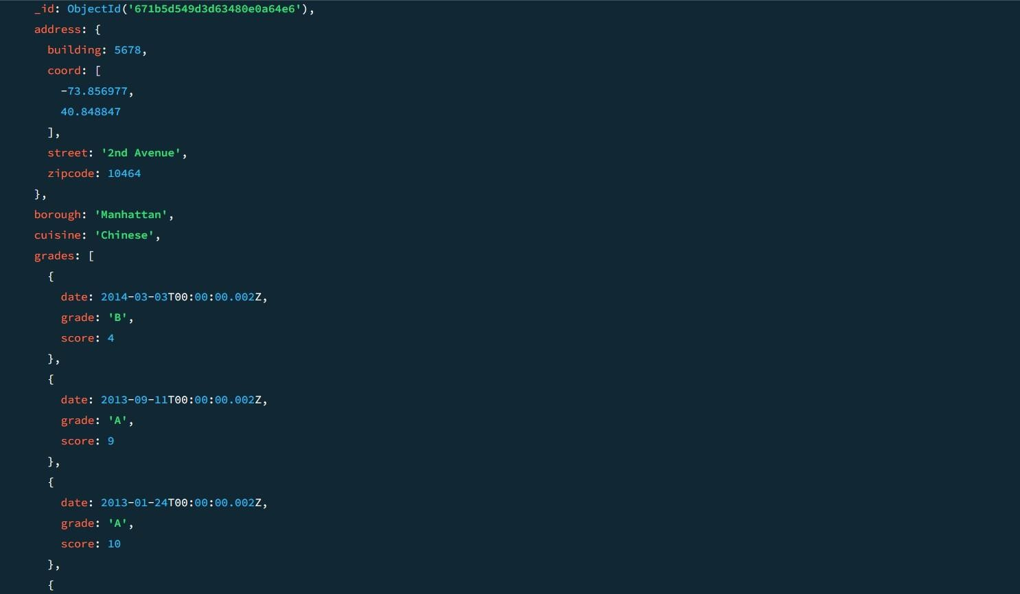

1. **Write a MongoDB query to find the restaurants that have at least one grade with a score of less than 5 and that are located in the borough of Manhattan or Brooklyn, and their cuisine is not American or Chinese.**

db.restaurants.find(

**{**

"grades.score": { $lt: 5 },

borough: { $in: ["Manhattan", "Brooklyn"] }, cuisine: { $nin: ["American", "Chinese"] }

**}**

**);**

1. **Write a MongoDB query to find the restaurants that have a grade with a score of 2 and a grade with a score of 6.**

db.restaurants.find(

**{**

grades: {

$all: [

{ $elemMatch: { score: 2 } },

{ $elemMatch: { score: 6 } }

**]**

**}**

**}**

**);**

**SAMPLE OUTPUT:-**

**{**

_id: ObjectId('671b92d339ec8a9bc8b6588b'), address: {

building: '1007', coord: [

-73.856077,

40.848447

**],**

street: 'Morris Park Ave', zipcode: '10462'

**},**

borough: 'Bronx', cuisine: 'Bakery', grades: [

**{**

date: 2014-03-03T00:00:00.000Z,

grade: 'A', score: 2

**},**

**{**

date: 2013-09-11T00:00:00.000Z,

grade: 'A', score: 6

**},**

**{**

date: 2013-01-24T00:00:00.000Z,

grade: 'A', score: 10

**},**

**{**

date: 2011-11-23T00:00:00.000Z,

grade: 'A', score: 9

**},**

**{**

date: 2011-03-10T00:00:00.000Z,

grade: 'B', score: 14

**}**

**],**

name: 'Morris Park Bake Shop', restaurant_id: '30075445'

**}**

**{**

_id: ObjectId('671b5c5f9d3d63480e0a64e4'), address: {

building: 1007, coord: [

-73.856077,

40.848447

**],**

street: 'Morris Park Ave', zipcode: 10462

**},**

borough: 'Bronx', cuisine: 'Bakery', grades: [

**{**

date: 2014-03-03T00:00:00.000Z,

grade: 'A', score: 2

**},**

**{**

date: 2013-09-11T00:00:00.000Z,

grade: 'A', score: 6

**},**

**{**

date: 2013-01-24T00:00:00.000Z,

grade: 'A', score: 10

**},**

**{**

date: 2011-11-23T00:00:00.000Z,

grade: 'A', score: 9

**},**

**{**

date: 2011-03-10T00:00:00.000Z,

grade: 'B', score: 14

**}**

**],**

name: 'Morris Park Bake Shop', restaurant_id: 30075445

**}**

1. **Write a MongoDB query to find the restaurants that have a grade with a score of 2 and a grade with a score of 6 and are located in the borough of Manhattan.**

db.restaurants.find(

**{**

borough: "Manhattan", grades: {

$all: [

{ $elemMatch: { score: 2 } },

{ $elemMatch: { score: 6 } }

**]**

**}**

**}**

**);**

1. **Write a MongoDB query to find the restaurants that have a grade with a score of 2 and a grade with a score of 6 and are located in the borough of Manhattan or Brooklyn.**

db.restaurants.find(

**{**

borough: { $in: ["Manhattan", "Brooklyn"] }, grades: {

$all: [

{ $elemMatch: { score: 2 } },

{ $elemMatch: { score: 6 } }

**]**

**}**

**}**

**);**

1. **Write a MongoDB query to find the restaurants that have a grade with a score of 2 and a grade with a score of 6 and are located in the borough of Manhattan or Brooklyn, and their cuisine is not American.**

db.restaurants.find(

**{**

borough: { $in: ["Manhattan", "Brooklyn"] }, grades: {

$all: [

{ $elemMatch: { score: 2 } },

{ $elemMatch: { score: 6 } }

**]**

**},**

cuisine: { $ne: "American" }

**}**

**);**

1. **Write a MongoDB query to find the restaurants that have a grade with a score of 2 and a grade with a score of 6 and are located in the borough of Manhattan or Brooklyn, and their cuisine is not American or Chinese.**

db.restaurants.find(

**{**

borough: { $in: ["Manhattan", "Brooklyn"] }, grades: {

$all: [

{ $elemMatch: { score: 2 } },

{ $elemMatch: { score: 6 } }

**]**

**},**

cuisine: { $nin: ["American", "Chinese"] }

**}**

**);**

1. **Write a MongoDB query to find the restaurants that have a grade with a score of 2 or a grade with a score of 6.**

db.restaurants.find(

**{**

$or: [

{ "grades.score": 2 },

{ "grades.score": 6 }

**]**

**}**

**);**

**SAMPLE OUTPUT:-**

**{**

_id: ObjectId('671b5d549d3d63480e0a64e9'), address: {

building: 2233, coord: [

-73.858177,

40.849447

**],**

street: '5th Avenue', zipcode: 10467

**},**

borough: 'Bronx', cuisine: 'American', grades: [

**{**

date: 2014-03-03T00:00:00.005Z,

grade: 'A', score: 10

**},**

**{**

date: 2013-09-11T00:00:00.005Z,

grade: 'A', score: 6

**},**

**{**

date: 2013-01-24T00:00:00.005Z,

grade: 'B', score: 12

**},**

**{**

date: 2011-11-23T00:00:00.005Z,

grade: 'A', score: 9

**},**

**{**

date: 2011-03-10T00:00:00.005Z,

grade: 'A', score: 14

**}**

**],**

name: 'Burger Bistro', restaurant_id: 30075450

**}**

**{**

_id: ObjectId('671b5dab56ec9972ca8f5daf'), address: {

building: 4455, coord: [

-73.858977,

40.849847

**],**

street: '7th Avenue', zipcode: 10469

**},**

borough: 'Bronx', cuisine: 'Thai', grades: [

**{**

date: 2014-03-03T00:00:00.007Z,

grade: 'A', score: 9

**},**

**{**

date: 2013-09-11T00:00:00.007Z,

grade: 'B', score: 6

**},**

**{**

date: 2013-01-24T00:00:00.007Z,

grade: 'A', score: 12

**},**

**{**

date: 2011-11-23T00:00:00.007Z,

grade: 'A', score: 8

**},**

**{**

date: 2011-03-10T00:00:00.007Z,

grade: 'B', score: 14

**}**

**],**

name: 'Thai Delight', restaurant_id: 30075452

**}**

**MOVIES COLLECTION**

1. **Find all movies with full information from the 'movies' collection that released in the year**

**1893.**

**db.movies.find({ year: 1893 });**

1. **Find all movies with full information from the 'movies' collection that have a runtime greater**

**than 120 minutes.**

**db.movies.find({ runtime: { $gt: 120 } }); SAMPLE OUTPUT:-**

**{**

**_id: ObjectId('573a1390f29313caabcd42ec'),**

**plot: 'An astronaut stranded on Mars must survive alone.', genres: [**

**'Sci-Fi', 'Drama'**

**],**

**runtime: 135, cast: [**

**'Matt Damon', 'Jessica Chastain'**

**],**

**poster: 'https://m.media-amazon.com/images/poster4.jpg', title: 'Mars Alone',**

**fullplot: 'An astronaut, left alone on Mars, struggles to survive with**

**limited resources while awaiting rescue.', languages: [**

**'English'**

**],**

**released: 2015-10-02T00:00:00.000Z,**

**directors: [ 'Ridley Scott'**

**],**

**rated: 'PG-13', awards: { wins: 8,**

**nominations: 6,**

**text: '8 wins & 6 nominations.'**

**},**

**lastupdated: '2021-08-09 17:22:30.000000000',**

**year: 2015, imdb: { rating: 8,**

**votes: 25650,**

**id: 443**

**},**

**countries: [ 'USA'**

**],**

**type: 'movie', tomatoes: { viewer: {**

**rating: 4.5,**

**numReviews: 2201,**

**meter: 93**

**},**

**fresh: 18, critic: { rating: 8.5,**

**numReviews: 25,**

**meter: 96**

**},**

**rotten: 1,**

**lastUpdated: 2021-07-19T21:20:55.000Z**

**}**

**}**

1. **Find all movies with full information from the 'movies' collection that have "Short" genre.**

**db.movies.find({ genres: "Short" }); SAMPLE OUTPUT:-**

**{**

**_id: ObjectId('573a1390f29313caabcd42e8'),**

**plot: 'A group of bandits stage a brazen train hold-up, only to find a**

**determined posse hot on their heels.', genres: [**

**'Short', 'Western'**

**],**

**runtime: 11, cast: [**

**'A.C. Abadie',**

**"Gilbert M. 'Broncho Billy' Anderson", 'George Barnes',**

**'Justus D. Barnes'**

**],**

**poster: 'https://m.media- amazon.com/images/M/MV5BMTU3NjE5NzYtYTYyNS00MDVmLWIwYjg tMmYwYWIxZDYyNzU2XkEyXkFqcGdeQXVyNzQzNzQxNzI@._V1_SY1 000_SX677_AL_.jpg',**

**title: 'The Great Train Robbery',**

**fullplot: "Among the earliest existing films in American cinema - notable as the first film that presented a narrative story to tell - it depicts a group of cowboy outlaws who hold up a train and rob the**

**passengers. They are then pursued by a Sheriff's posse. Several scenes have color included - all hand tinted.",**

**languages: [ 'English'**

**],**

**released: 1903-12-01T00:00:00.000Z,**

**directors: [ 'Edwin S. Porter'**

**],**

**rated: 'TV-G', awards: { wins: 1,**

**nominations: 0,**

**text: '1 win.'**

**},**

**lastupdated: '2015-08-13 00:27:59.177000000',**

**year: 1903, imdb: { rating: 7.4,**

**votes: 9847,**

**id: 439**

**},**

**countries: [ 'USA'**

**],**

**type: 'movie', tomatoes: { viewer: {**

**rating: 3.7,**

**numReviews: 2559,**

**meter: 75**

**},**

**fresh: 6, critic: { rating: 7.6,**

**numReviews: 6,**

**meter: 100**

**},**

**rotten: 0,**

**lastUpdated: 2015-08-08T19:16:10.000Z**

**}**

**}**

1. **Retrieve all movies from the 'movies' collection that were directed by "William K.L. Dickson" and include complete information for each movie.**

**db.movies.find({ directors: "William K.L. Dickson" });**

1. **Retrieve all movies from the 'movies' collection that were released in the USA and include complete information for each movie.**

**db.movies.find({ countries: "USA" });**

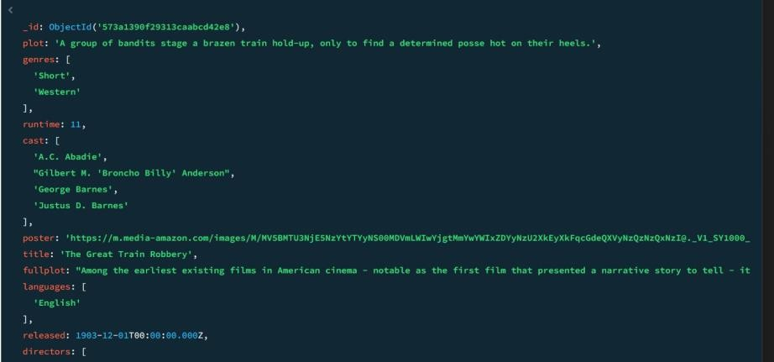

1. **Retrieve all movies from the 'movies' collection that have complete information and are rated**

**as "UNRATED".**

**db.movies.find({ rated: "UNRATED" });**

1. **Retrieve all movies from the 'movies' collection that have complete information and have received more than 1000 votes on IMDb.**

**db.movies.find({ "imdb.votes": { $gt: 1000 } });**

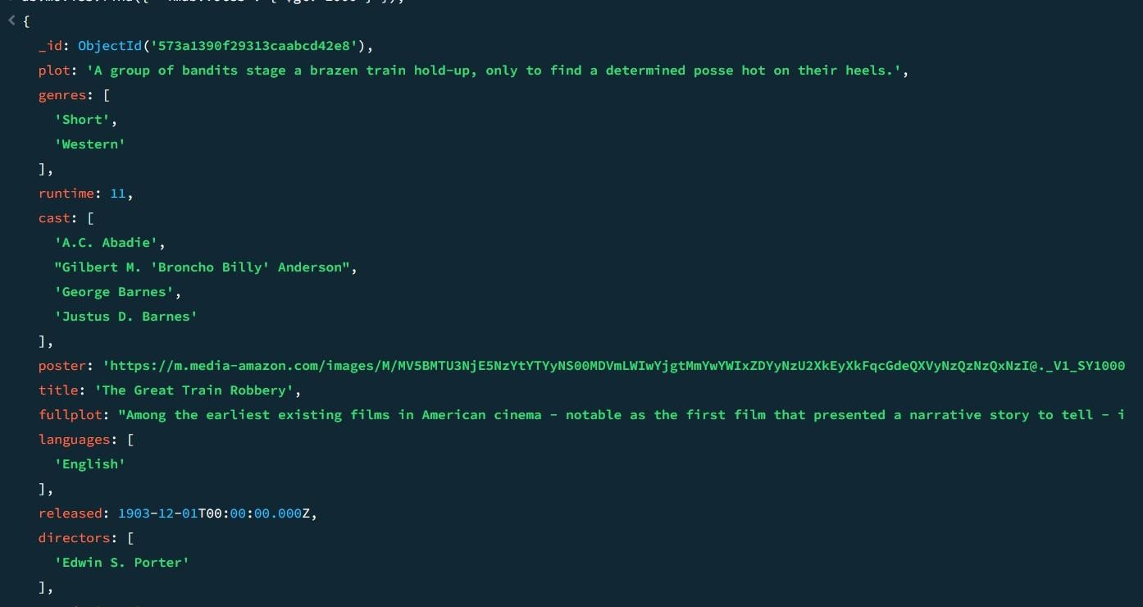

1. **Retrieve all movies from the 'movies' collection that have complete information and have an IMDb rating higher than 7.**

**db.movies.find({ "imdb.rating": { $gt: 7 } });**

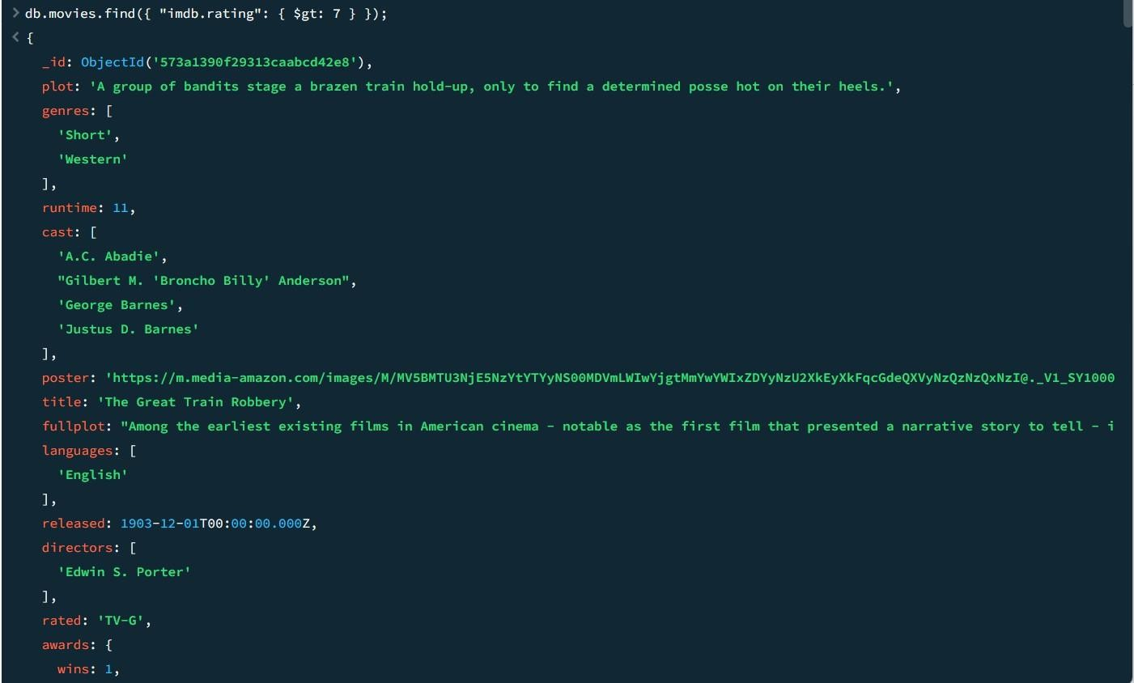

1. **Retrieve all movies from the 'movies' collection that have complete information and have a viewer rating higher than 4 on Tomatoes.**

**db.movies.find({ "tomatoes.viewer.rating": { $gt: 4 } });**

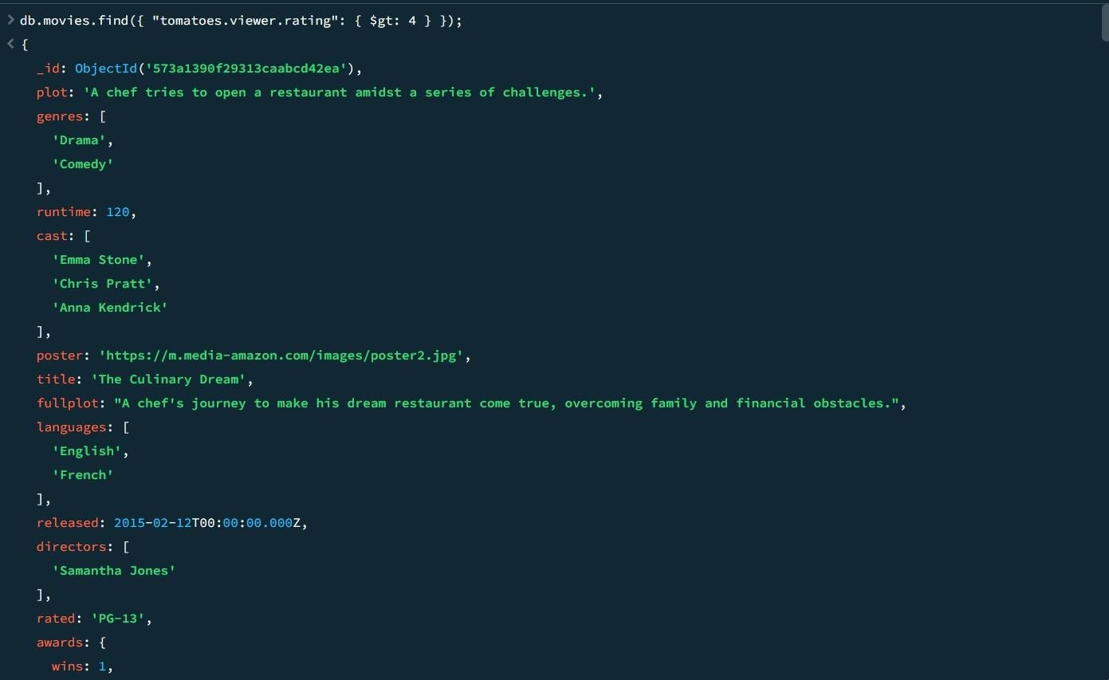

1. **Retrieve all movies from the 'movies' collection that have received an award.**

**db.movies.find({ "awards.wins": { $gt: 0 } });**

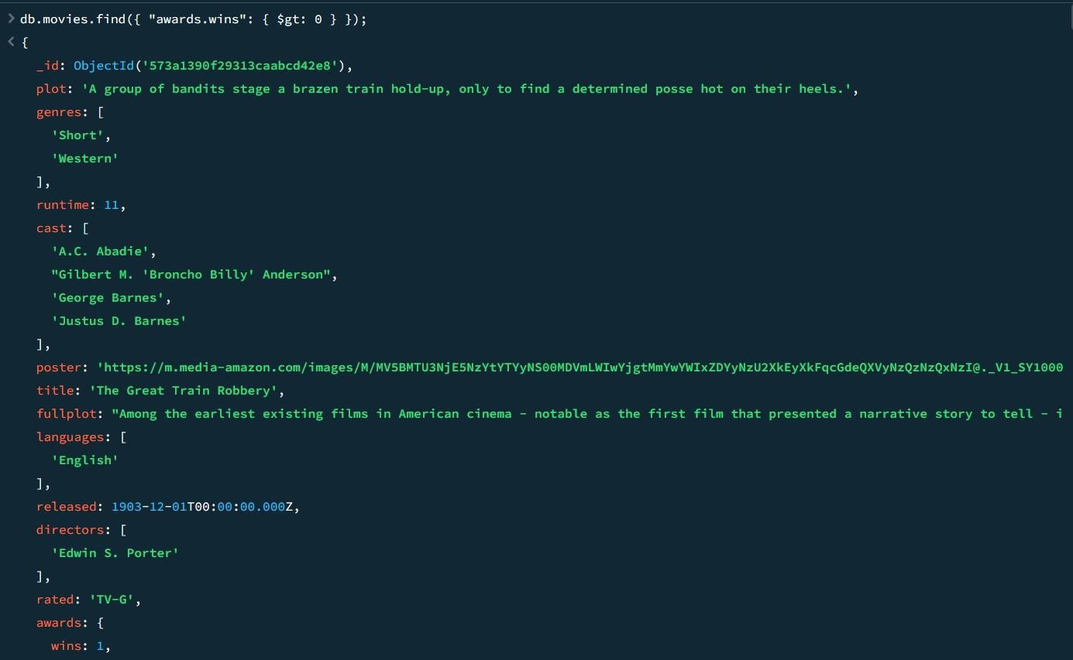

1. **Find all movies with title, languages, released, directors, writers, awards, year, genres, runtime, cast, countries from the 'movies' collection in MongoDB that have at least one nomination.**

**db.movies.find(**

**{ "awards.nominations": { $gt: 0 } },**

**{**

**title: 1,**

**languages: 1,**

**released: 1,**

**directors: 1,**

**writers: 1,**

**awards: 1,**

**year: 1,**

**genres: 1,**

**runtime: 1,**

**cast: 1,**

**countries: 1**

**}**

**);**

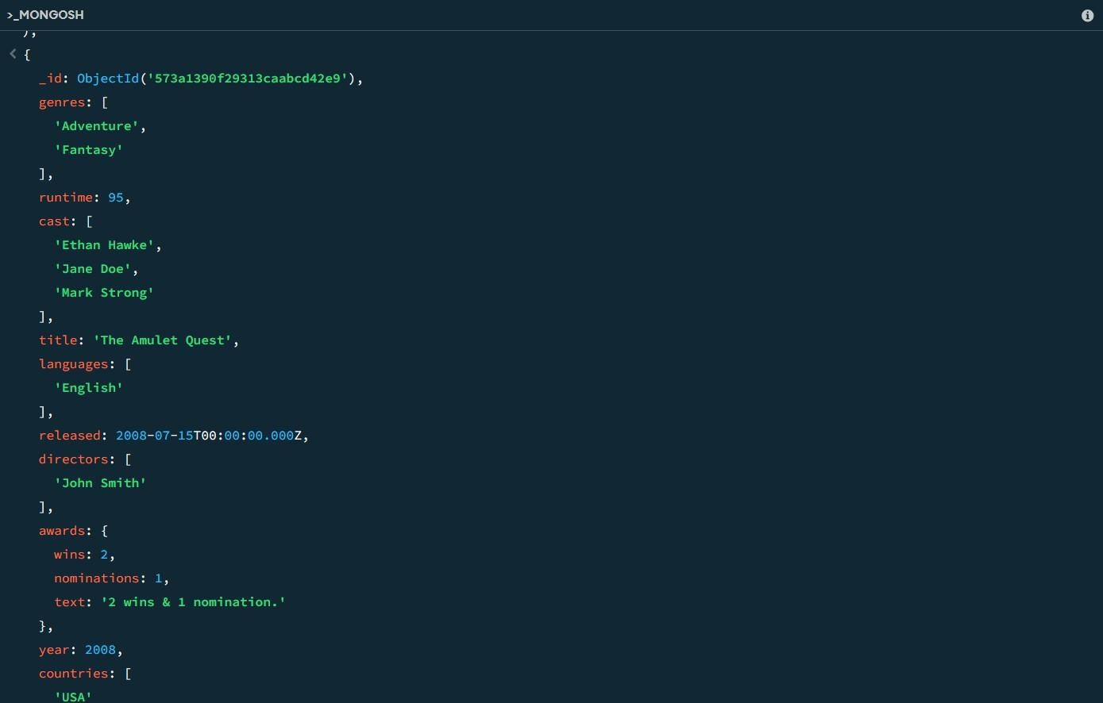

1. **Find all movies with title, languages, released, directors, writers, awards, year, genres, runtime, cast, countries from the 'movies' collection in MongoDB with cast including "Charles Kayser".**

**db.movies.find(**

**{ cast: "Charles Kayser" },**

**{**

**title: 1,**

**languages: 1,**

**released: 1,**

**directors: 1,**

**writers: 1,**

**awards: 1,**

**year: 1,**

**genres: 1,**

**runtime: 1,**

**cast: 1,**

**countries: 1**

**}**

**);**

1. **Retrieve all movies with title, languages, released, directors, writers, countries from the 'movies' collection in MongoDB that released on May 9, 1893.**

**db.movies.find(**

**{ released: ISODate("1893-05-09T00:00:00Z") },**

**{**

**title: 1,**

**languages: 1,**

**released: 1,**

**directors: 1,**

**writers: 1,**

**countries: 1**

**}**

**);**

**14. Retrieve all movies with title, languages, released, directors, writers, countries from the 'movies' collection in MongoDB that have a word "scene" in the title.**

**db.movies.find(**

**{ title: { $regex: /scene/i } },**

**{**

**title: 1,**

**languages: 1,**

**released: 1,**

**directors: 1,**

**writers: 1,**

**countries: 1**

**}**

**);**

|  |  |  |
| --- | --- | --- |
| **Ex.No.: 15** | | **OTHER DATABASE OBJECTS** |
| **Date:** | 27/09/2024 |

1) Create a sequence to be used with the primary key column of the DEPT table. The sequence should start at 200 and have a maximum value of 1000. Have your sequence increment by ten numbers. Name the sequence DEPT_ID_SEQ.

**CREATE SEQUENCE DEPT_ID_SEQ START WITH 200**

**INCREMENT BY 10**

**MAXVALUE 1000 NOCACHE NOCYCLE;**

1. **Write a query in a script to display the following information about your sequences: sequence name, maximum value, increment size, and last number**

## SELECT SEQUENCE_NAME, MAX_VALUE, INCREMENT_BY, LAST_NUMBER

**FROM USER_SEQUENCES;**

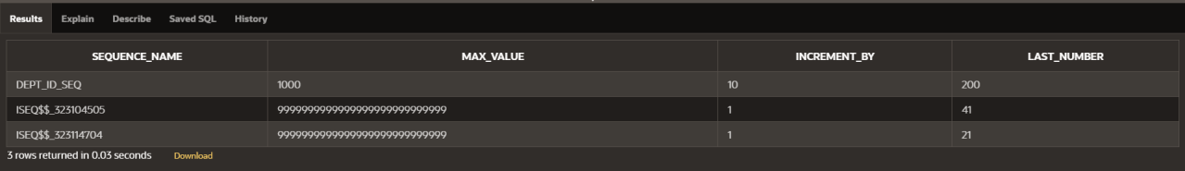

3 Write a script to insert two rows into the DEPT table. Name your script lab12_3.sql. Be sure to use the sequence that you created for the ID column. Add two departments named Education And Administration. Confirm your additions. Run the commands in your script.

INSERT INTO DEPT (DEPT_ID, DEPT_NAME) VALUES (DEPT_ID_SEQ.NEXTVAL, 'Education');

## INSERT INTO DEPT (DEPT_ID, DEPT_NAME)

VALUES (DEPT_ID_SEQ.NEXTVAL, 'Administration');

## SELECT * FROM DEPT

WHERE DEPT_NAME IN ('Education', 'Administration');



1. **Create a non unique index on the foreign key column (DEPARTMENT_ID) in the EMPLOYEES table.**

CREATE INDEX employees_department_id_idx ON EMPLOYEES (DEPARTMENT_ID);

1. **Display the indexes and uniqueness that exist in the data dictionary for the EMP table.**

## SELECT INDEX_NAME, UNIQUENESS FROM USER_INDEXES

**WHERE TABLE_NAME = 'EMPLOYEES';**



|  |  |  |
| --- | --- | --- |
| **Ex.No.: 16** | | **CONTROLLING USER ACCESS** |
| **Date:** | 03/10/2024 |

1. **What privilege should a user be given to log on to the Oracle Server? Is this a system or an object privilege?**

The privilege a user should be given to log on to the Oracle Server is the CREATE SESSION privilege.

Type of Privilege: This is a system privilege. GRANT CREATE SESSION TO username;

1. **What privilege should a user be given to create tables?**

the user needs the CREATE TABLE privilege.

The CREATE TABLE privilege allows the user to create new tables in their own schema.

GRANT CREATE TABLE TO username;

1. **If you create a table, who can pass along privileges to other users on your table?**

When you create a table, only you as the table owner (or a user with the ADMIN OPTION or GRANT ANY PRIVILEGE system privilege) can grant privileges on your table to other users.

GRANT SELECT ON your_table TO other_user;

1. **You are the DBA. You are creating many users who require the same system privileges. What should you use to make your job easier?**

As a DBA, to simplify the process of granting the same system privileges to multiple users, you should use roles.

CREATE ROLE my_role;

GRANT CREATE SESSION TO my_role; GRANT CREATE TABLE TO my_role;

GRANT my_role TO user1; GRANT my_role TO user2;

1. **What command do you use to change your password?**

ALTER USER username IDENTIFIED BY new_password;

1. **Grant another user access to your DEPARTMENTS table. Have the user grant you query Access to his or her DEPARTMENTS table.**

Grant Access to Your DEPARTMENTS Table

GRANT SELECT ON your_username.DEPARTMENTS TO other_user;

Grant Query Access to Other User's DEPARTMENTS Table

GRANT SELECT ON other_user.DEPARTMENTS TO your_username;

1. **Query all the rows in your DEPARTMENTS table.**

## SELECT * FROM DEPARTMENT;

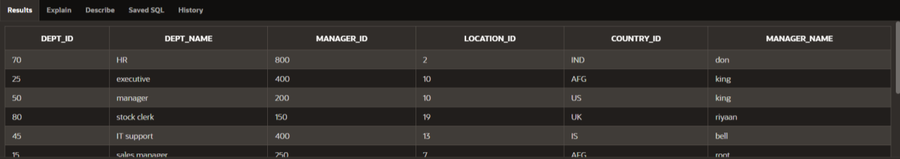

1. **Add a new row to your DEPARTMENTS table. Team 1 should add Education as department number 500. Team 2 should add Human Resources department number 510. Query the other team‘s table.**

INSERT INTO DEPARTMENT(dept_id,

DEPT_NAME,manager_id,location_id,country_id,manager_name) VALUES (500, 'Education',300,12,'BAN','ball');

INSERT INTO DEPARTMENT(dept_id,

DEPT_NAME,manager_id,location_id,country_id,manager_name) VALUES (510, 'Human Resources',150,10,'AUS','john');

## SELECT * FROM DEPARTMENT;



1. **Query the USER_TABLES data dictionary to see information about the tables that you own.**

## SELECT * FROM USER_TABLES;

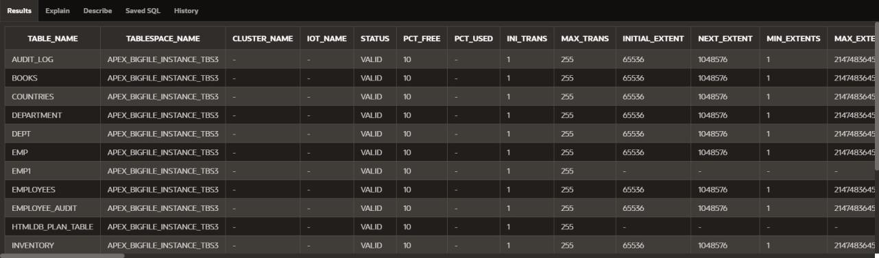

1. **Revoke the SELECT privilege on your table from the other team.**

REVOKE SELECT ON team1_user.DEPARTMENTS FROM other_user;

1. **Remove the row you inserted into the DEPARTMENTS table in step 8 and save the changes.**

**DELETE FROM DEPARTMENT WHERE DEPT_ID IN (500, 510);**